Patoss, the Professional Association of Teachers of Students with Specific Learning Difficulties: Patoss Dyslexia Charity

PRESS RELEASE

EMBARGOED UNTIL: 00.01pm Wednesday 1 October 2025

1 October 2025

Specialist Teacher Association Achieves Charity Status to Broaden Impact for Learners with Specific Learning Difficulties

Patoss, the UK’s largest professional association for specialist teachers and professionals supporting learners with specific learning difficulties (SpLDs), is proud to announce its new status as a registered charity. Retaining its full name, the association will also use the working name of Patoss Dyslexia Charity.

This milestone marks a significant step in Patoss’ mission to empower educators, raise awareness and improve outcomes for individuals with SpLDs such as dyslexia, dyspraxia/DCD, dyscalculia, and ADHD.

Lesley Browne, CEO of Patoss, said:
"Becoming a charity strengthens our commitment to supporting the professionals who make a difference every day in the lives of learners with SpLDs. It allows us to expand our reach, deepen our impact, and ensure that high-quality support is accessible to all who need it."

Lynn Greenwold OBE, Patoss Advisor on Policy and Educational Development and Chair of SASC * (SpLD Assessment Standards Committee) added:
“I am proud to see Patoss is now recognised as a charity. We have always worked in the public interest and our new charitable status underlines that. We hope this will enable us to do even more to help people with Specific Learning Difficulties (SpLD) succeed in their education and workplace by nourishing the professionals who teach, assess and support them.”

Patoss member, Holly, said:
“Being a Patoss member has been incredibly beneficial for my professional development as a tutor and assessor. The wide range of professional support available has significantly enhanced the support I can offer to students and adult learners.

Mentoring support has provided me with bespoke advice on assessment practice and diagnostic decisions, boosting my confidence as an assessor and positively impacting the experience of those I assess. Through the APC renewal process, I have received detailed, expert feedback on my practice, helping me target areas for improvement. Ongoing access to support from other professionals and experts through the Patoss forums has provided a platform to share experiences, seek advice, and stay connected with the community.

The breadth of training available, both live and on-demand, fits perfectly with the juggle of family and work life, enabling me to maintain a high standard of continuous professional development. Being listed on the tutor index has ensured that individuals who need support can access it effectively.

Overall, being a Patoss member has provided me with tools, knowledge, and community support to enhance my practice and better support my students and adult learners.”

As a charity, Patoss will continue to offer expert-led accredited training and CPD, mentoring, policy guidance and practical resources, while also increasing its advocacy and outreach efforts across education and workplace settings.

The transition also opens new opportunities for collaboration, funding and community engagement, enabling Patoss to further its vision of a more inclusive society where every learner can thrive.

About Patoss
Founded over 30 years ago, Patoss is the UK’s largest professional membership body dedicated to supporting those who work with learners with SpLDs. Its members include specialist teachers, assessors, SENCOs, tutors, lecturers and other professionals across education and employment sectors.

Notes to Editors
Patoss Dyslexia Charity (Registered Charity No. 1213705, Registered Company No. 05280223)

For further information, interviews, or media enquiries, please contact:
E: info@patoss-dyslexia.org
T: 01386 257808
W: www.patoss-dyslexia.org

* SASC: https://www.sasc.org.uk/

Logo for use on a white background:
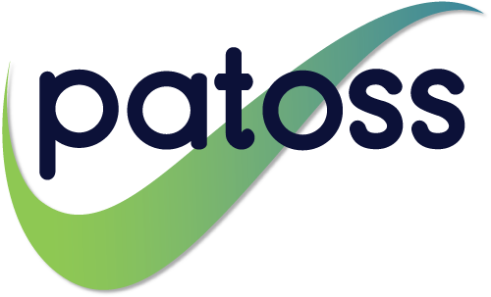

Logo for use on a dark background:



