Newham Philharmonic: the new orchestra for young Londoners

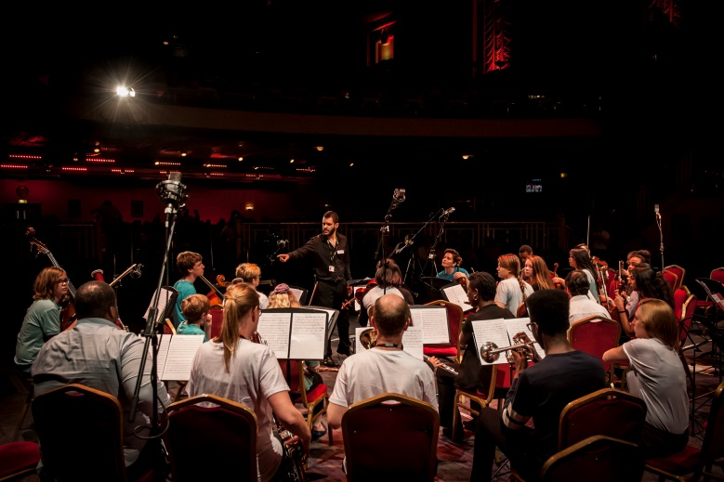
This November Newham Music has launched an exciting new orchestra for young Londoners: Newham Philharmonic. The mission of the orchestra is to give young people from Newham and across the capital and further-afield the opportunity to perform together in a high quality orchestra at famous venues across London as well as community venues across Newham, under the guidance of a professional conductor.
The idea for Newham Philharmonic came from Newham Music’s CEO Tom Kerstens who has been so inspired by the talent in east London. Newham Philharmonic is a direct response to that inspiration as it will be an aspirational orchestra, based in east London drawing on talent from Newham, across the capital and further-afield. Tom Kerstens had this to say:
“We are delighted to launch Newham Philharmonic, the new orchestra for young Londoners. As the city moves eastwards, we want to draw on the capital’s talented young musicians to come and create a brand new orchestra from scratch with us that is based in our beloved east London.”
Matthew Scott Rogers, one of the most accomplished young British conductors of his generation, will lead Newham Philharmonic for its debut in April 2016 at the Barbican Centre and Lister School with a performance of Symphony No. 1 in C minor by Johannes Brahms.
Newham Philharmonic are currently recruiting orchestra members who are aged 16 – 25 and play an orchestral instrument such as Violin, Viola, Cello, Double Bass, Flute, Oboe, Clarinet, Bassoon, French horn, Trumpet, Trombone or Timpani to grade 8 standard or above to be part of this exciting new project which has big ambitions for the future.
If you are interested please visit www.newham-music.org.uk/our-projects/newham-philharmonic or email newham.philharmonic@newham-music.org.uk for more information. Deadline for applications is 18 December 2015.
- ENDS -
Notes: Newham Music was awarded Music Education Hub Leader status for Newham by Arts Council England and the Department for Education in May 2012 and has gone on to become an award-winning hub. We are committed to providing high-quality music education to all children and young people throughout the borough and to ensure that all 5-18 year olds have the opportunity to sing and learn a musical instrument, to progress to the next level and play with other children and young people as part of an ensemble or choir.
For further information, please contact:
Liz Coomb, Projects, Marketing & PR Officer, Newham Music
Telephone: 020 3598 6260
Email: liz.coomb@newham-music.org.uk
www.newham-music.org.uk

