PRESS RELEASE (for immediate release).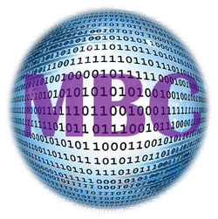
MBC Digital Business Cards.
From “My Business Client Ltd”
Contact: Andrew Nice. Director.
Ph: - 01420 477080, 07503689397.
Eml:a.nice@mybusinessclient.com
Website: www.mbcard.co.uk
My Business Client Ltd is pleased to launch “My Business Card”

Introduction to e-business cards .
MBC are proud to launch their new electronic business cards. The MBC business card contains all the information of
your old cardboard card as well as links to live information such as social media, directions, Google Street View, your
web site and email. You can update all cards using a business control centre for your business 24/7. Therefore the business
controls the cards centrally for all employees. The business can monitor card activity, add cards and update cards easily.

The recent global pandemic has reinforced our understanding that businesses will need to change and some business
practices of old will also need to change. Since Covid-19, passing over cardboard business cards is now an extinct practice.
Social distancing and non-physical contact between those conducting business is here for the foreseeable future.
What is an e-business card?
The MBC card is stored on your mobile phone so that you always have them with you.
The MBC business card can be sent to clients and customers via text/SMS messaging from anywhere globally 24/7.
Businesses worldwide can set up and design their own cards from the easy business card builder. Simply insert your
web site and start designing.
What beneficial features does it have over and above a "cardboard card'?
- MBC cards will save your business money. No need for reprints for minor changes.
- They are easy to use. Send via SMS/Text, and save to your phone.
- Easy update 24/7 adding to your marketing, ie change the background to suit
events and promotions.
- No cutting down trees, printing, waiting or shipping and so reduces carbon.
- If your business has 5000 business cards in the market and you change your
background then all cards worldwide instantly have that change!
- Easy billing via direct debit monthly for live cards only. No additional costs
- Only £3.00 per card per month plus Vat.

What other advantages does an e-business card have over the traditional "hard card"?
1) Each e-business card sent to a client is registered on your own CRM system. You always have the source contact details should an employee leave.
2) The quantity of e-business cards issued by employees are recorded and easily comparable between employees should you require to do so.
3) Gone are the days where your business card is kept in an office drawer, wasted due to detail changes.
4) e-business card backgrounds can be changed for promotions or seasonal reasons.

5) There are many more reasons to choose My Business Card. Visit the web site and watch the short video.

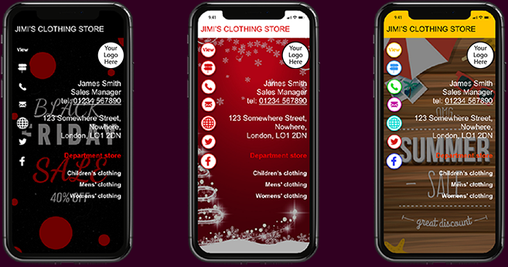

My Business Client Ltd (MBC) is an established publisher, working with Local Authorities and key business organisations. MBC provide the “Its Local” service nationally. Its Local is a directory of local businesses. The new MBC Business Card is owned by MBC. The new development is not an app. It is a cloud based application. The MBC business card will be a game changer in the way business people interact, store and gain contact information. The card becomes it own marketing tool. Future development will add more value to having “My Business Card”.
MBC Ltd.
Visit:- www.mbcard.co.uk
ENDS.

