Children’s charity launches bumper ‘The Big Community’ text raffle

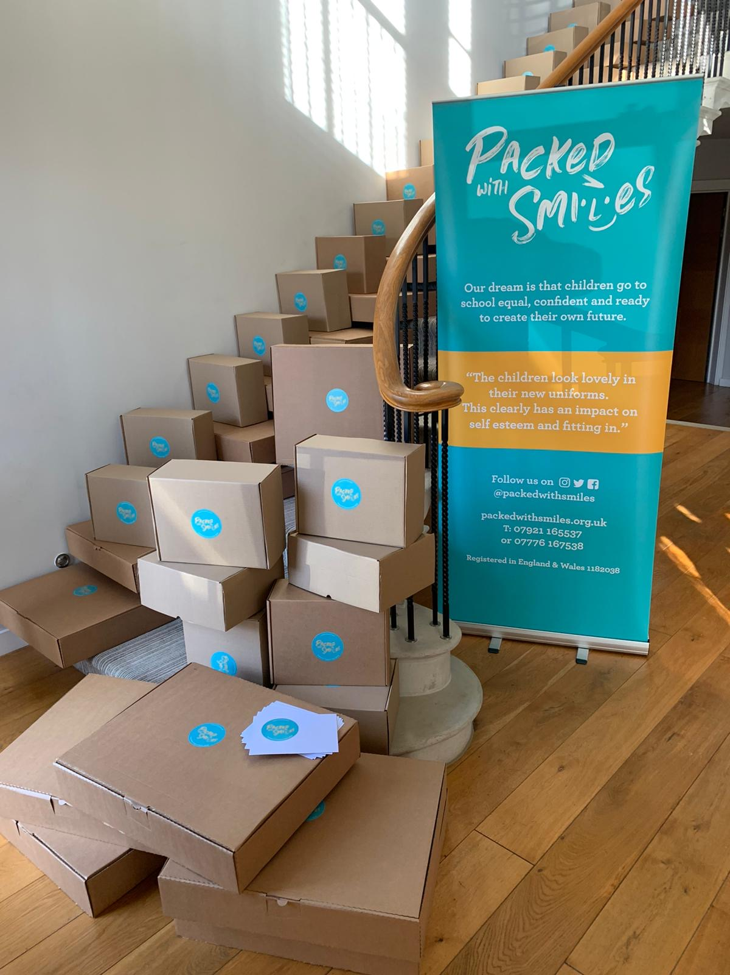

Children’s charity Packed With Smiles has launched a bumper text raffle of 50 lots to support their work, coinciding with World Children’s Day.

The 50 lots were donated by local businesses to support the text raffle, which launched Friday 20th November on digital fundraising platform DONATE™, with luxury hampers, paddle boarding sessions and limited edition prints up for grabs.

The charity, which supports families facing financial difficulties by providing basic school essentials, has set up the text raffle to fundraise for an unexpected funding gap due to the pandemic and a determination to ensure the charity's support to those who have come to rely on the cause.

Elle Beadle, Chair of Trustees, says: “Our marketing concept was no tickets, no cash, no hassle. A ticket free raffle that didn't involve cash immediately caught people's attention.

“The text raffle means that the charity is able to raise funds, increase our profile, give something back to our business community and continue our work of supporting families facing financial hardship, by supplying new school uniform parcels and other school essentials, so that children can fully participate in school. We have a dream that all children are given the opportunity to attend school feeling equal, confident and ready to create their own future and the pandemic won’t stop us.”

Local businesses participating in The Big Community Raffle can use the opportunity to proudly shout about their unwavering commitment and awareness to and of the wider community, even in the most challenging of climates, something that means the world to Packed With Smiles.

The auction launched Friday 20th November and is due to end on Sunday 13th December.

For a full list of prizes, visit the raffle page. To enter, simply text the code name of the prize you want to win to 70970 and you will be entered into the raffle. Each text costs £5* and counts as one entry. *Standard network charges may apply. Winner contacted by text on 14 Dec 2020.

~ Ends ~

For further information or to set up media interviews, contact:
Elle Beadle - elle@packedwithsmiles.org.uk
Fiona Flanagan - Fiona@theforgecommunications.com

About the National Funding Scheme

The National Funding Scheme (NFS), operating under the DONATE™ brand, provides a range of mobile fundraising tools to maximise fundraising campaigns.

Launched in 2013, DONATE™ (www.easydonate.org) is a platform that allows the UK public to conveniently donate via touch and SMS text. In response to the COVID-19, National Funding Scheme has removed the dormancy fee until 31st May 2020.

Organisations wishing to register with DONATE™ should go to http://www.nationalfundingscheme.org/become-a-partner-organisation/ or for further information see www.nationalfundingscheme.org/faqs-about-donate for full terms and fees.

