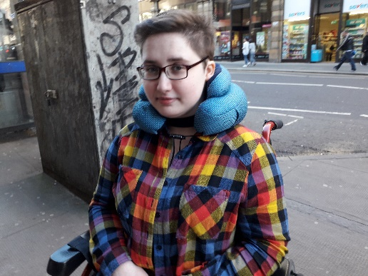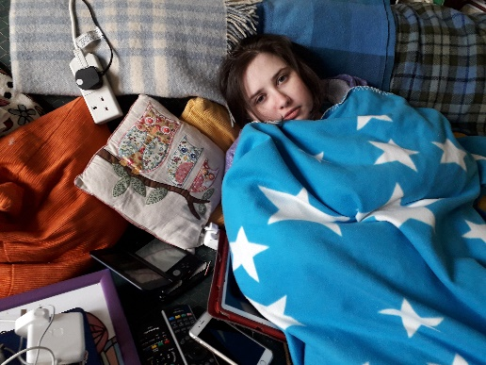

Isabel Laennec
I was just about to start my second year of secondary school in Glasgow when I fell ill with ME in 2011. I’d had a pretty rough first year of secondary, involving being bullied and consequently moving schools, and I was very emotionally drained and unhappy. It was at the start of what would have been my second year, when I came down with a cold which then developed into a throat, chest and ear infection. These infections took 3 courses of antibiotics to get rid of, but even once the infections had gone I still felt exhausted. At first they told me I was just recovering from having done 3 courses of antibiotics. Then they told me it was post-viral fatigue. After 6 months, I went to see my paediatrician who said that I had now been ill for long enough that they could officially diagnose me with ME.

I’ve not been offered any treatments for my ME by my doctors since I first fell ill – and even then I’m not sure they were ‘treatments’ as such. The day I was diagnosed, I had it recommended to me that I lose weight to help my fatigue, because I was 14 and they said I was finished growing. They didn’t offer me any support or guidance on how to do this responsibly or safely however, and I ended up taking it to an extreme and nearly developing anorexia. They offered me CBT for my mental and physical health, but I never understood what the aim of the CBT was and I didn’t have a good relationship with my CBT therapist. That all went badly wrong because I was told that I wasn’t allowed to get a different therapist, and it kept being implied that if I didn’t do the CBT then I wasn’t trying to get better. Because I was too ill to be in school, they sent a hospital tutor to my house. My concentration was very poor and it hurt me immensely to sit up in a chair for any length of time, and after a few sessions my parents asked the hospital tutor if they could talk about this because they didn’t feel it was working. The tutor agreed that it wasn’t working, but she said that she thought I wasn’t motivated to get better and I was “too cosy at home”. A few years back I did try Mickel Therapy privately. This seemingly worked miracles, but after a few months I started slowly getting worse again. 8 months or so later and I totally crashed, and was back to where I was before trying the therapy. I don’t think it made me worse than I was before starting it, but it meant that I had to cancel and drop out of a lot of responsibilities that I’d signed up for such as volunteering, babysitting, and while I was only doing one subject at school I had to delay finishing the course until the next year because it was coming up to the end of the course and I had deadlines and exams but was nowhere near well enough for that.

I’ve been treated by paediatricians, GPs, and on one occasion have seen an A&E doctor. For the most part they’ve just not had much knowledge about ME, but have listened when I’ve explained my symptoms to them and what helps me. The time I went to A&E was for severe muscle weakness, I was getting rapidly worse every day and I was terribly afraid. My mother took me to the hospital, where I had blood tests done and was then told that my ME was all in my mind and I just needed to use my mind to work my muscles. However, the next day we got a phone call to say that my blood tests had shown I was anaemic and I needed to take iron tablets, and I started to feel a little better soon after. I was very glad I didn’t listen to the doctors ignoring my symptoms by saying that it was just ME, because if I had continued to go on while being so anaemic it could have been dangerous for me.

ME has changed my life and my family’s life greatly. I missed 3 years of secondary school entirely, while only managing the last 2 years very part time. My mother has had to give up her job and most of her life to be my official carer. My illness has fluctuated over the years so there’s been times when I’ve been able to get glimpses of what it would be like to be a ‘normal teenager’, but I do feel I have missed out on the chance to have fun teenage years, and definitely the chance to earn qualifications in school at the same time as everyone else. It used to be so hard for me watching groups of school kids walking to and from school in groups, laughing and having fun. Now I’m jealous of the people my age who are able to be at uni, or hold down a job. I feel like my parents and I have had to sacrifice a lot because of my illness. I need a lot of assistance right now as I can’t care for myself in many ways. Nowadays I manage my symptoms with a lot of bedrest, using a wheelchair when I’m well enough to leave the house, and I’ve recently started using noise-cancelling headphones to help prevent sensory overload when I’m out of the house.

To speak to Isabel contact her mother, Christine Laennec on cedartree18@btinternet.com

