Sample of Protocol-based Token

Anton Galenovich
DAO IPCI Mitigation Token (MITO) is sought to provide for exchange of numerous and diverse asset-based tokens representing societal costs mitigation outcomes. Namely and in the first instance, GHG emissions limited rights and reductions (carbon emission quotas and credits) are the assets that become fungible via MITO and MITO market. Distinctive characteristics of the two types of DAO IPCI tokens are that only one of them, MITO, is based on the protocol to integrate the ecosystem while the rest of tokens represent diverse regulated mitigation compliance units as underlying.
Furthermore, mitigation compliance units like carbon emission quotas and credits, other emission or effluent credits, renewable energy certificates, and even quantified social benefits (‘environmental units’) are regulated by wide variety of programs and in principle, nothing can prevent jurisdictions, entities, businesses, NGOs or individuals from launching new and independent result-based mitigation program. New programs are eligible to issue new mitigation outcomes-based tokens subject to compliance with the program rules and independent assurance. Existing and newly launched programs may create ‘sovereign’ representations in DAO IPCI in the form of autonomies (DAOs). These “representations’ should be encouraged to adhere to MITO emission protocol instead of issuing new protocol-based tokens. While maintaining decentralized nature of DAO IPCI ecosystem.
MITO emission protocol is subject to performance under these complex requirements.
Mitigation Token (or MITO) is the key element to provide for transactions’ efficiency and integrity of DAO IPCI ecosystem.
As explained in more detail below, MITO is a protocol-based token and designed to serve inter alia a digital carbon-pricing instrument, a digital CO2 cost equivalent.
Mitigation Token sole purpose is to provide market exchange operations with environmental units issued to the environmental units’ registries by independent entities under the rules and supervision of operators, which accept MITO policy.
MITO is inherently appropriate and designed for executing DAO IPCI smart contracts, including placing and executing buying and selling of environmental units’ orders, as a collateral under security deposit contract, MITO market commission fee.
MITO emission implies strict limitation of the potential amount of emission, strict adherence to the interests of the MITO holders, the interests of the issuers of environmental units and participating environmental programs’ compliers.
To avoid dilution and preserve the interests of MITO holders, 50% of MITO newly issued after initial emission of 10,000,000, shall be distributed to existing MITO holders.
MITO holders receive the right to exchange them for environmental units at MITO market.
Genesis Operator and the Team of Founders shall perform initial emission and offering of Mitigation Token.
Initial emission of Mitigation Token is limited by 10,000,000. Initial emission and offering of Mitigation Token shall be performed in two stages: Presale and ICO. Amount of MITO for presale is limited by 10% of total initial emission of Mitigation Token.
Further (‘post-ICO’) emission of MITO shall be governed by MITO emission protocol and pool of decentralized autonomous organizations, which agree on MITO emission policy and abstain from emission of alternative digital currencies to be exchanged for environmental units or other independently assured mitigation outcomes (“MITO pool of DAOs”). Further emission of MITO shall be possible after MITO Pool of DAOs is formed and MITO emission protocol is refined but no sooner than one year after the start of initial emission and distribution.
The ultimate quantitative limit for emission of Mitigation Token is equal to conservative evaluation of global carbon emissions budget of 600 billion units (tCO2e) with ultimate time limit for emission set to the end of the 21st century, which actually limits ultimate emission below the number of mitigation compliance units to be definitely issued within this period.
Post-ICO MITO emission protocol shall ensure direct correlation of current cap for MITO emission and the sum of environmental units secured and accessible via environmental units’ registries minus the amount of MITO previously issued. Thus, MITO-to-environmental units’ ratio shall be predetermined by the protocol and reach maximum at the stage of ICO, and with growth of environmental units issued further MITO emissions shall be close to one with a certain lag in favor of environmental units due to the time needed to agree on and perform further emissions (Fug.7).
Figure 1 – Correlation of Mitigation Token and environmental units
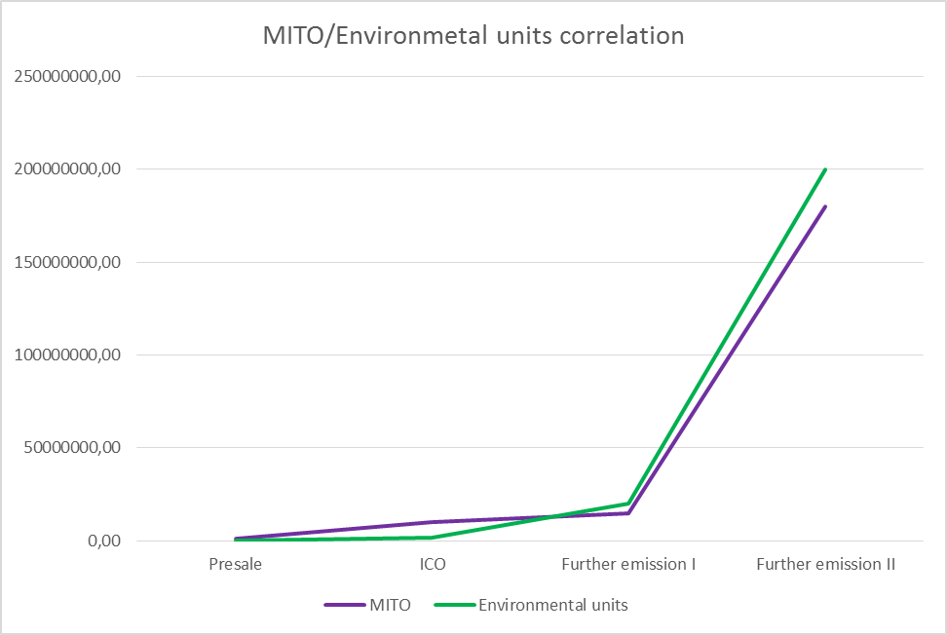
As MITO emission protocol limits their amount to the sum of environmental units accessible via environmental units registries of ‘the MITO Pool of DAOs’, thus MITO serves inter alia as a digital carbon price equivalent, a digital carbon cost equivalent. Along with global trend toward the increase of value of climate change mitigation outcomes and cost of GHG emissions, this algorithm would support long-term increase of value of Mitigation Token and of DAO IPCI mitigation ecosystem.
Current post-ICO MITO emission protocol design suggests that:
- Any Operator, who has entered the MITO pool of DAOs and agreed to MITO emission policy, would be eligible to initiate emission of MITO in the amount not exceeding the sum of environmental units secured and accessible via MITO pool of DAOs environmental units’ registries minus the number of MITO previously issued subject to approval of the MITO pool of DAOs;
- To protect early buyers and holders of MITO post-ICO emission shall be preformed not earlier than one year after the ICO starting date
- 50% of MITO newly issued after initial emission of 10,000,000, shall be distributed to existing MITO holders, 50% to the Operator who initiates their emission;
- An Operator may use MITO to support project development (project pipeline) through the security deposit contract by providing MITO as a collateral;
- MITO pool of DAOs may deactivate the Security deposit contract in case it is compromised, and return MITO collateral.

Figure 2 –Mitigation Token post-ICO emission model
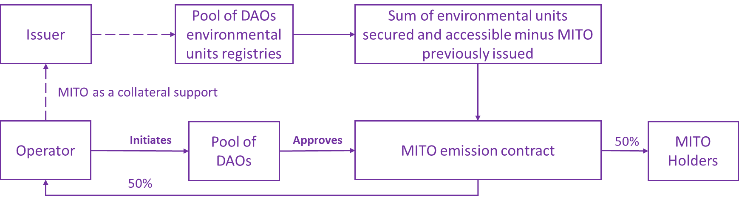
Specific MITO emission parameters shall be made public and open for comments at ipci.io at least 10 days ahead of the emission.
Climate change and other societal costs’ mitigation programs are welcome to join efforts in developing common ecosystem and non-profit consortium.

