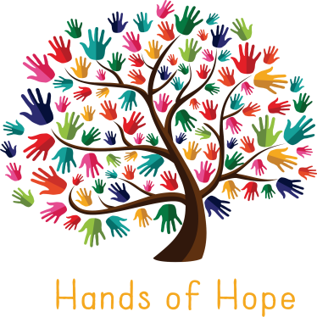
Press Release
1st May 2017
Hands of Hope
Registered Charity 1168016

LEND US A HAND!

PEASMARSH CHARITY LAUNCHES VOLUNTEER SOS
Hands of Hope (HOH), the recently launched Peasmarsh charity, today announced its "Lend us a Hand" appeal for local volunteers to help tackle childhood obesity and loneliness through the production of locally grown, organic food.
The charity is undertaking a number of local activities in the community to generate vital funds required to support their projects including Man the Van, where Volunteers get the chance to run a Cook Van while attending local festivals & events; Sell The Veg where help is required selling organic fruit & veg at weekly Farmer's Markets; Grow to Show, where volunteers donate their home-grown surplus produce & Prepare to Care, where cooking is done at home using HOH produce.

Sow To Grow involves volunteers sowing, growing and harvesting 4 acres of glorious East Sussex countryside and Join the Club is calling for Peasmarsh residents to come together in running a weekly seniors club in the Village Hall.
Hands of Hope has already established itself in the wider Rye community and has received a huge amount of support from local councillors, elderly charities and schools.
James Doran, Founder, Hands of Hope, “Our charity will only be as strong as its volunteers which is why we’re relying on support to join us in building this voluntary community together to help the lonely and educate our children about healthy eating.” -Ends-
Further information
Hands of Hope (HOH) is a registered charity based in Peasmarsh, working IN and FOR the local community with two main aims - to tackle loneliness and childhood obesity, through the production of locally grown, organic food.
Alarmingly, research shows that loneliness and social isolation can be as damaging for a person's health as smoking 15 cigarettes a day and increasingly, 1 in 3 children are becoming over-weight or obese.
Farming 4 acres of Soil Association accredited land in Peasmarsh, we currently produce and sell our fruit and vegetables for the sole purpose of raising funds and awareness to support Planned Projects to help tackle these issues.
Planned Projects Include:
Hawkhurst Community Farm and Garden is a "walled" area of land where we aim to create an all-inclusive welcoming environment for those sections communities our charity supports. A place that will stimulate local school children to learn about healthy, organic food - where it comes from and how to grow it. A place where the elderly can choose what they want to do - whether to simply sit and have a chat and a cup of tea, enjoying the surroundings or to physically engage, carrying out tasks such as planting, weeding, picking or preparing. Our aim is to accommodate both the elderly and the children, with the former bringing their life-long experience and the latter their energy and enthusiasm.
Our Schools Programme sees us working hand in hand with local primary schools and colleges to fund and create a working garden, enabling young people to work with experts in the planning of a garden, where they grow and maintain the fruit and vegetables and ultimately understand how their food is produced from seed to plate - enhancing their learning by using these spaces as a "living class room". Our programme will benefit the schools towards achieving their educational curriculum targets and afford these establishments the opportunity to market and sell their produce in order to generate vital school funds. We are currently working with Robertsbridge Community College on The Living Garden Project.
Our Lunch Club Programme
Hands of Hope currently provide support for the Northiam Seniors club every Thursday. Northiam Seniors create an environment where all are welcome. It is a place that people are genuinely welcomed and look forward to attending every week. We are interested in launching Joins Our Club Programme and would like to start by establishing a lunch club in Peasmarsh, as the last club was cancelled due to funding. We are genuinely interested in hearing from anyone who could offer their support or who would be interested in either attending or volunteering, either in Peasmarsh or other surrounding villages where there is a need.
For further information or to volunteer please contact us at info@hohcharity.co.uk or call Mandy Doran on 07968 333 097 or visit our website: www.hohcharity.co.uk
Hands of Hope is a registered charity number 1168016.
