|  |  |
| --- | --- |
|  | News Update |

Ballard introduces new scalable FCmove®-XD fuel cell engine with class-leading power density at IAA TRANSPORTATION 2024

# **Fuel cell supplier’s latest high-performance module for heavy-duty vehicles, scalable from 120-360kW, will make its European debut at IAA 2024**

# **For Immediate Release – Aug. 21, 2024**

**VANCOUVER, CANADA** – Ballard Power Systems (NASDAQ: BLDP; TSX: BLDP) will unveil the high-performance FCmove®-XD fuel cell engine, including the first public demonstration of its 240kW configuration, at the leading transportation event. Ballard is exhibiting in hall 24, booth C01 from 16-22 September, at the Hannover Messe Center, Germany.

Building on nine generations of fuel cell development, the compact design of the new FCmove®-XD module delivers class-leading volumetric power density, with an open architecture design approach that also makes the fuel cell the smallest and lightest in its power range.

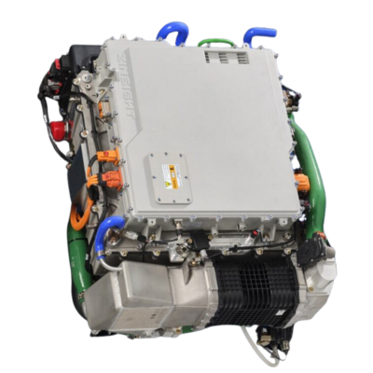  
Ballard’s FCmove®-XD fuel cell engine

“The power and performance requirements of the truck market are particularly demanding due to the wide range of use cases, including high vehicle utilisation rates and payload requirements,” said Dave Mucciacciaro, Senior Vice President and Chief Commercial Officer, Ballard. “One of the compelling features of our new FCmove®-XD is scalability based on modularity. We can offer customers efficient integration of 120kW, 240kW, and 360kW solutions dependent on truck class, use case, and duty cycle. For example, two modules, totalling 240kW of power output, can be easily installed in the engine compartment of a typical Class 8 heavy-duty truck, enhancing standardization and redundancy.”

Delivering the highest volumetric power density in the industry for heavy-duty applications, the FCmove®-XD features an engine volumetric power density of 0.36 kW/L and gravimetric power density of 0.48 kW/kg. The scalable 120kW fuel cell module integrates DC/DC regulated output, enabling up to three modules to operate as one system with a single interface, capable of delivering a combined 360kW of zero-emission power output.

With a design life of 30,000+ hours of operation – or over one million miles in truck operation at typical duty cycles – the FCmove®-XD is developed to deliver class-leading durability and low total cost of ownership, including a long driving range of 800km – subject to onboard hydrogen storage capacity.

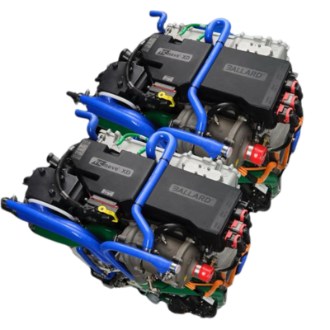  
The FCmove®-XD’s scalable nature means a 240kW configuration can easily and conveniently be integrated into a Class 8 truck’s engine compartment

Enabled by the open architecture design and other new design advances, the powerful and compact FCmove®-XD module delivers several important performance improvements including:

* 120kW power output from Ballard’s latest high-performance single stack
* 33% reduction in total parts count, significantly improving reliability and reducing costs
* Ultra-high peak system efficiency at >60%, enabling improved fuel consumption (lower total cost of ownership) and efficient heat rejection
* Wide operating temperature range, up to 95°C
* Integrated power controller incorporates DC/DC converter, air compressor inverter, and a power distribution unit, along with proprietary software controls, enables improved engine operation and efficiency
* Rapid up and down transient times, with an innovative hot stand-by mode enabling rapid power increase
* Improved manufacturability with >50% assembly time reduction
* Compliance with applicable safety codes and standards

“We are laser focused on strengthening the economic value proposition for our heavy-duty mobility customers,” concludes Mucciacciaro. “With the unveiling of our ninth generation of fuel cell module, the FCmove®-XD is developed for volume production and deployment to deliver competitive CAPEX and total cost of ownership values across heavy-duty truck segments.”

**About Ballard Power Systems**

Ballard Power Systems’ (NASDAQ: BLDP; TSX: BLDP) vision is to deliver fuel cell power for a sustainable planet. Ballard zero-emission PEM fuel cells are enabling electrification of mobility, including buses, commercial trucks, trains, marine vessels, and stationary power. To learn more about Ballard, please visit [www.ballard.com](http://www.ballard.com).

Media contacts:

**Jonna Christensen**

[Jonna.christensen@ballard.com](mailto:Jonna.christensen@ballard.com)

+44 7510 385820

**Thomas Davies**

[Thomas.davies@ballard.com](mailto:Thomas.davies@ballard.com)  
+44 7851 478656