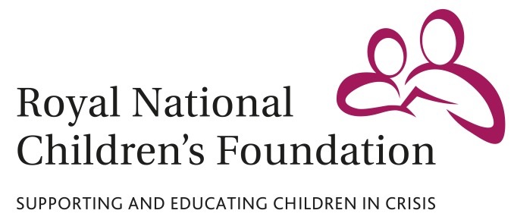

MEDIA RELEASE

31 March 2016

**Cambridge woman celebrates remarkable physical transformation by running the London Marathon for children’s charity**

A woman from Cambridge who lost six stones over six years is training to run her first marathon in aid of a children’s charity which helped transform the life of one of her closest friends.

Ella Lyons, 33 and from Hardwick in Cambridge, will run the London Marathon on 24 April to raise money for the Royal National Children’s Foundation (RNCF). The charity supports children facing crisis by enabling them to attend boarding school, away from the difficulties they face at home.

Ella said: “I have always wanted to run the London Marathon - my dad used to run the event a lot when I was a small girl. Now is my time. I feel proud, privileged and a little scared!

“I’m running the London Marathon for the Royal National Children’s Foundation, as the charity helped a friend of mine when she was growing up in the 1990s. The RNCF enables young people to better their futures. The charity does fantastic work.”

Ella’s participation in the London Marathon marks the culmination of a six-year physical fitness journey, which has made a huge difference to her life.

Ella explained: “About six years ago, I was six stone heavier than I am now. I took a year off work and I ran and worked out every day. It changed my life. I'm glad I did it.

“I love running - it makes me feel happy and free.”

Ella feels she is currently on course to complete the London Marathon in “about 4 hours and 15 minutes”. She said: “I would like to do it in less than four hours, but I think that I might struggle to do that. Getting around without stopping is really what I am hoping for!”

To sponsor Ella’s London Marathon run, visit <http://uk.virginmoneygiving.com/fundraiser-web/fundraiser/showFundraiserPage.action?userUrl=ella-lyons-SAVMLMBONDS3332016-11896> or search for Ella Lyons on <http://uk.virginmoneygiving.com/>

David Bassom, Director of Marketing and Fundraising at the Royal National Children’s Foundation, said: “All fund raised by Ella’s London Marathon run will directly support our work with vulnerable and disadvantaged children. The Royal National Children’s Foundation is currently working with more children than ever before and we are continuing to respond to record demand for our help.”

**For all media enquiries please contact:**

David Bassom / Robin Smart

Tel: 07818 865750

Email: [dbassom@rncf.org.uk](mailto:dbassom@rncf.org.uk) / [rsmart@rncf.org.uk](mailto:rsmart@rncf.org.uk)

RNCF, Sandy Lane, Cobham, Surrey KT11 2ES

**Notes to Editors**

The Royal National Children’s Foundation (RNCF) is a registered charity that helps children facing abuse, neglect or trauma at home by providing them with the opportunity to move into a supported education environment. The RNCF currently enables nearly 400 vulnerable and disadvantaged children to attend state and independent boarding schools and day schools. As well as paying school fees, the RNCF also funds counselling, educational school trips and holidays for vulnerable children, many of whom have never had a holiday.

The charity was founded in 1827 by Dr. Andrew Reed, with Queen Victoria as its Patron. Its current patron is the Princess Royal, who plays a very active role in the RNCF.

The RNCF is entirely voluntary funded, and depends on the generosity of supporters to continue its vital work. Registered charity no. 310916.

ENDS