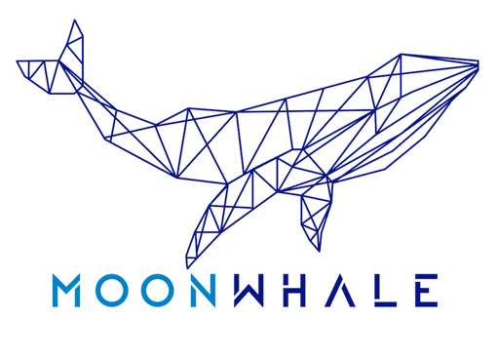
MOONWHALE
VENTURES
FOR IMMEDIATE RELEASE

MOONWHALE SECURES IMPORTANT CORPORATE CLIENT

Press release

Singapore, 5th January 2019 —
Furthering our dedication to drive the global adoption of blockchain technology, Moonwhale Ventures is pleased to announce our next major client, MoneyFi.

The scope of blockchain technology for remittance is increasing in emerging markets. Distributed Ledger Technology (DLT) can serve as the backbone of a new cross-border payments infrastructure to solve inefficiencies and provide fast, more affordable and secure service.

MoneyFi is the brainchild of a US retail banking support organization, Odyssey Financial Group. Leveraging the Octagon Platform’s rapid deployment rate of its ATM Network, MoneyFi will address the growing market demands for a better alternative in remittance. Its non-traditional approach is purpose-built to drastically reduce transaction fee costs, providing financial inclusion for non-banked and unbanked people.

CEO & Founder of Odyssey Financial Group, Sebastian Ponceliz, commented on their partnership with Moonwhale Ventures:
“After the review of several proposals, we decided to go with Moonwhale Ventures not just only for its solid and clear ideas regarding the crypto asset ecosystem but also for the professionalism of their management. Finally, we believe that Moonwhale can expand the revolutionary concept of MoneyFi worldwide.”

In addition to providing technical, operational and financial support, advisory on Blockchain tech implementation, and an industry network of 50k+ connections, Moonwhale will undertake the task of building attractive investment and token models, marketing and go-to-market strategies. Moonwhale shall, but not limited to, prepare MoneyFi with the necessary prerequisites of becoming a leading remittance system which branches out globally.

“We believe MoneyFi has what it takes to build a world-class Internet of Money with its innovative approach,” said Danny Christ, CEO and Co-Founder, Moonwhale Ventures. “MoneyFi’s mission aligns with our core belief in blockchain technology’s revolutionary capabilities in optimizing the value chain, in this case, payment and remittance services.”

About Odyssey Financial Group:
Odyssey Financial Group is a dynamic retail banking support organization operating from South Florida, deploying its services within all US. They provide the best enterprise experience to customers (ATM entrepreneurs and investors) with a seasoned team of professionals in administration, logistics and systems.

For more information, please visit: http://odysseygroupus.com/

About Moonwhale Ventures:
Moonwhale Ventures is a Blockchain Technology Advisory and Investment Platform, helping three types of businesses on Blockchain implementation, expansion/ new venture building, fundraising, go-to-market strategies:

- Tech Startups (ICOs, STOs) - full life-cycle from business setup to technology/ token development to fundraising
- SME, MNC, Listed Companies to finance expansion by Tokenization (STO) of assets
- SME, MNC, Listed Companies to improve security/ value chain through blockchain technology application

Moonwhale then, delivers/ showcases these vetted projects as investment opportunities on the Moonwhale Investment Platform, where VC, LP, other Funds or high net worth individuals can securely invest, individually or managed through our fund.

For more information, please visit: https://moonwhale.io/

###

