Open your door to organic food with local roots this July
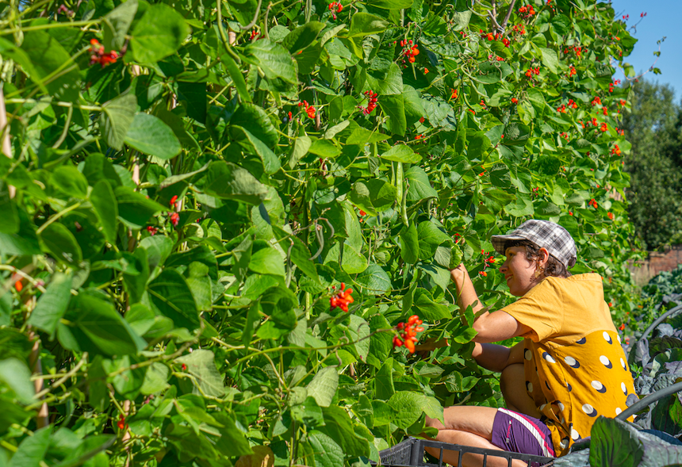
1st July 2021 sees the launch of a new veg box scheme ‘Hope Farm Organics’, run by Hands of Hope Charity. The scheme delivers fresh fruit, veg and honey grown at Hope Farm in Peasmarsh, and at Hope Farm Garden in Hawkhurst. Customers can add eggs, diary, meat, and pantry products from local artisan suppliers.
Proceeds from weekly boxes, which start at £12.50, support delivery of Hands of Hope’s wellbeing projects tackling food poverty, rural isolation, and loneliness with specific focus on marginalised groups.
‘What’s not to love?’ says Mandy Doran, Hands of Hope Trustee. ‘Fresh, affordable, seasonal, local organic produce delivered to your door. Buying veg this way nurtures wellbeing in your community. It’s local, pesticide free, plastic free and seasonal so it benefits the planet too.’
Projects supported by the Hope Farm Organics veg box scheme include:
- Food banks: Hands of Hope donates tonnes of fresh organic produce grown at Hope Farm Garden to local food banks and community support groups.
- Holiday Hunger: The Charity cooks free, nutritious food for local children during school holidays.
- Education: Hands of Hope’s visits local schools to teach children where their food comes from.
- Therapeutic Horticulture: The Charity provides social horticulture wellbeing activities at Hope Farm Garden in Hawkhurst.
- Work experience and accredited training: Hands of Hope delivers training and experience to help people develop skills in horticulture.
- Outdoor classroom: An outdoor learning space where adults and children can learn about horticulture and healthy, sustainable living.
Mandy continues, ‘Hope Farm Organics is another step forward in Hands of Hope’s mission to improve health and wellbeing in Rother, Hastings and West Kent, by connecting people with nature and each other.’
Demand is expected to be high, so, if you live in the following postcode areas TN5, TN17, TN18, TN19, TN31, TN32, TN33 and TN36 and are interested in participating please visit our Farm Shop at www.hohcharity.co.uk.

ENDS
For more information contact sosi.kaskanian@hohcharity.co.uk
www.hohcharity.co.uk
www.get-growing.co.uk/
Images and image credits available on this link (please credit photographer, Ann Chown) https://www.dropbox.com/sh/wql1dqsil50s613/AAD7jGjdfihiX5WbZbXtmbJva?dl=0

