FOR IMMEDIATE RELEASE - 15 December 2016 08:00 GMT

Study reveals local business performance in relation to central London Tube lines

- Bakerloo line identified as top-performing line in both annual turnover and growth

DueDil, the data intelligence company that helps businesses find, verify and monitor their business relationships, has identified the top-performing Tube lines in Zone 1 based on business turnover and growth.

The study reveals that companies on the Bakerloo line represent both the highest average annual turnover and average growth rate when compared to businesses adjacent to other lines.

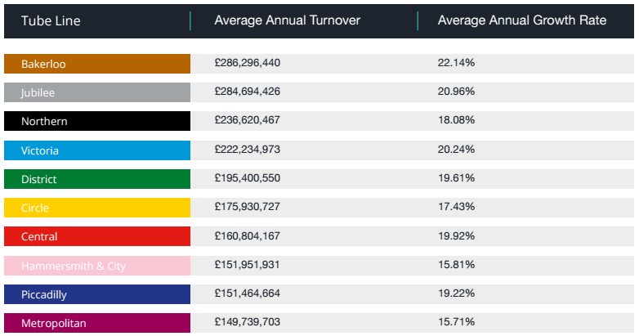

Every Tube line achieved an average annual growth rate of at least 15%, and averaged 18.69% across the lines. This compares favourably businesses across the rest of the UK, which have an average growth of 13.64%

Among individual stations, Waterloo has the highest average turnover and Bayswater has the highest average growth rate.

Companies included in the study were required to have a reported annual turnover in excess of £5 million and have a registered trading address in central London. The 11,475 companies that fit these criteria were subsequently mapped to their closest Zone 1 Tube station using latitude and longitude information from Postcode.io.

The Waterloo & City line is excluded from the results as it consists of only two stations, which does not offer a fair comparison with other lines.

Waterloo has the highest average annual turnover at £2,536,771,284 (£2.53 billion). It is followed by Paddington (£783 million), Victoria (£575 million), Cannon Street (£447 million) and St. Paul's (£283 million).

The high average turnover of companies local to Waterloo is primarily due to the presence of Royal Dutch Shell Group PLC and its subsidiary, Shell Trading International Limited. Both companies rank in the top three for annual turnover among all businesses included in the study.

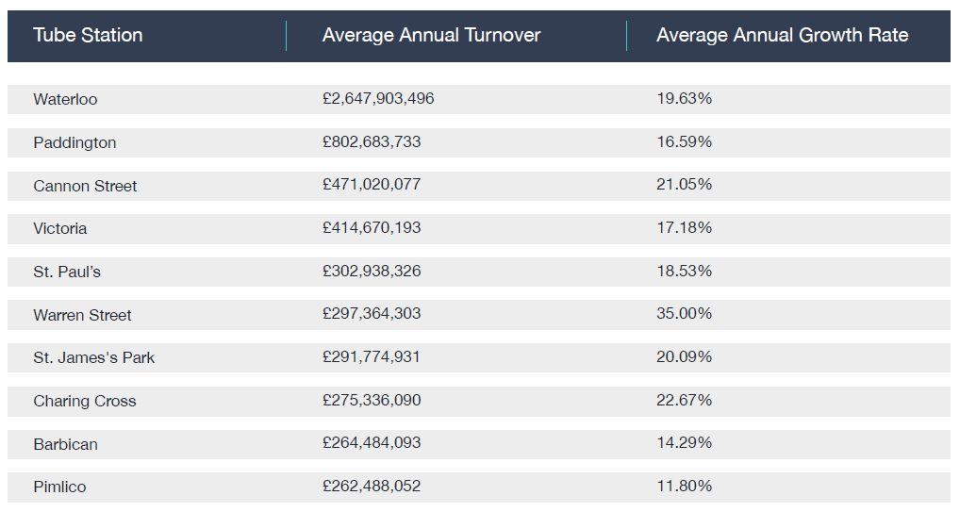

Bayswater has the highest average growth rate at 77.75%. The station is followed by Gloucester Road (66.72%), Embankment (44.73%), Warren Street (35%) and Mansion House (33.84%).

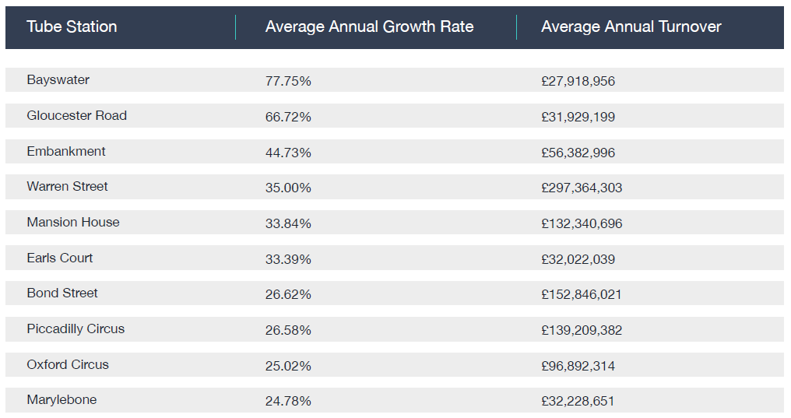

-ENDS-

Appendix

Top 10 companies on annual turnover:

Company | Annual Turnover | Annual Growth Rate | Closest Station
Royal Dutch Shell PLC | £183,000,000,000 | -37.08% | Waterloo
HSBC Holdings PLC | £61,642,441,860 | -3.35% | Tower Hill
Shell Trading International Limited | £47,113,500,415 | -42.66% | Waterloo
Audible Limited | £43,664,011,000 | 48.23% | Barbican
Unilever PLC | £41,366,671,843 | 9.98% | Notting Hill Gate
Prudential Public Limited Company | £41,305,000,000 | -31.30% | Cannon Street
Societe Generale | £34,450,453,195 | -37.84% | Tower Hill
Glencore Energy UK Ltd | £33,118,512,817 | -31.17% | Green Park
BHP Billiton PLC | £30,120,790,877 | -31.97% | Victoria
Barclays Bank PLC | £29,753,000,000 | -1.02% | Tower Hill

Top 10 companies on annual growth rate:

Company | Annual Growth Rate | Annual Turnover | Closest Station
CMEGroup International Market Data Limited | 992.77% | £158,539,000 | St Paul’s
BG South Asia LNG Limited | 935.99% | £679,702,102 | Waterloo
SFDC EMEA Data Centre Limited | 923.69% | £11,679,474 | Liverpool Street
Abbeygate Helical(C4.1) LLP | 918.31% | £6,276,769 | Oxford Circus
Close Brothers Finance PLC | 887.57% | £11,637,755 | Liverpool Street
Interhealth Canada (UK) Limited | 887.41% | £6,074,114 | Gloucester Road
Aberdeen Infrastructure Investments (No 5) Limited | 878.85% | £7,115,751 | Mansion House
Greenland (United Kingdom) Investment Limited | 878.73% | £17,870,042 | Moorgate
Citigroup Capital UK Limited | 874.81% | £63,665,000 | Tower Hill
Beit Halochem UK | 866.18% | £7,522,445 | Marylebone

Top 5 companies for annual turnover on the Bakerloo Line:

Company Name | Annual Turnover | Annual Growth Rate
Royal Dutch Shell PLC | £183,000,000,000 | -37.08%
Shell Trading International Limited | £47,113,500,415 | -42.66%
Astrazeneca PLC | £18,271,093,692 | -69.30%
BAE Systems PLC | £16,787,000,000 | 87.90%
BG Energy Holdings Limited | £11,941,137,322 | -16.28%

Top 5 companies for annual turnover in Waterloo:

Company Name | Annual Turnover | Annual Growth Rate
Royal Dutch Shell PLC | £183,000,000,000 | -37.10%
Shell Trading International Limited | £47,113,500,415 | -42.70%
BG Energy Holdings Limited | £11,941,137,322 | -16.30%
BG Global Energy Limited | £5,621,828,000 | 404.20%
Shell U.K. Limited | £4,600,000,000 | -31.50%

Top 5 companies for annual growth in Bayswater:

Company Name | Annual Growth Rate | Annual Turnover
Woodsford Litigation Funding LTD | 783.44% | £7,147,000
Paul Elliot LTD | 184.00% | £6,044,268
Reward Gateway (UK) Ltd | 18.12% | £171,699,318
Planet Organic Limited | 16.57% | £24,226,437
Kingsridge Limited | 8.97% | £10,333,020

About DueDil

DueDil is about intelligence: for every team, in every company, in every industry, that does business with other businesses.

DueDil helps solve the two biggest problems faced by companies – how to find new customers and avoid the risks associated with dealing with these businesses.

We help teams to identify the right companies to sell to, get insights into their business, and make a sale. But that’s only one part of the equation: dealing with the wrong business can severely damage a company. We provide the intelligence to prevent this.

At DueDil, we believe that one person’s risk is another’s opportunity and every team in every company should have the power to make intelligent decisions.

Since 2011, the London-based financial technology company has raised nearly $30m from respected investors in the US and UK, including Oak Investment Partners, Passion Capital and Notion Capital.
http://www.duedil.com

Contact details

Amelia Henderson
DueDil
amelia@duedil.com, (07) 8507 63009

