KAMPOS reports record sales & is certified with the prestigious Butterfly Mark

- Thanks to record sales, KAMPOS sold approximatively 11,000 recycled plastic PET bottles and almost 2,000 kg of abandoned fishing nets or other regenerated nylon in its first 3 months of trading.

- KAMPOS has officially been certified with the prestigious Butterfly Mark accreditation, for its commitment to sustainability.

For high-res images and press release, please use the following link:
https://www.dropbox.com/sh/2spzx4ggbsqp4v3/AACt4wapr0tMub4UlYh8HfcXa?dl=0

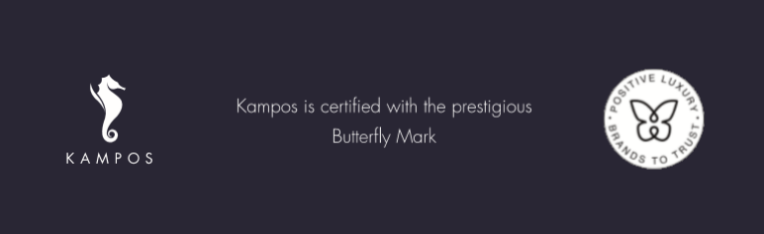

Milan, Italy - 16 September 2020: Every victory counts in the world of sustainability, and the newly launched luxury fashion brand, KAMPOS, committed to producing 100% sustainable products and tackle the marine pollution in the Mediterranean Sea, wants to celebrate each of them. Launched 5 months ago with the mission of creating a world with a conscience now and for generations to come, KAMPOS celebrates the success of its first collection with stellar results. The brand has also recently earnt the Butterfly Mark accreditation by Positive Luxury, the only international trust mark awarding luxury brands on their commitment to creating a positive impact on people and the planet.
In its steps towards a better and more sustainable world, KAMPOS has made significant impact through a sell-out first season of swimwear (despite the pandemic). Materials used to make the products sold equate to approximatively 11,000 recycled plastic PET bottles and almost 2,000 kg of abandoned fishing nets or other regenerated nylon being used. The brand has also donated part of its revenue to its partner One Ocean Foundation.
"As we grew our distribution channels with our first store opening in Porto Cervo and our first lighthouse wholesale partner, Juno Zest in San Benedetto del Tronto, we are extremely pleased to note such a successful response from consumers. We would like to thank our customers who believe in the quality of our products and above all, why we do what we do. It’s a very promising start and we’re excited to continue to grow and learn with our consumers."
At the end of August, KAMPOS took another step in its sustainability journey . The brand officially joined the Positive Luxury community and was certified with the influential Butterfly Mark.
The Butterfly Mark accreditation offers transparency at points of sale, equipping consumers to make more informed purchasing decisions. It enables consumers to clearly identify luxury brands that meet the highest standards of verified innovation and environmental performance that contribute to a better world.
By being part of the Positive Luxury brand community, KAMPOS demonstrates its commitment to sustainable and ethical business practices. Find out more about the Butterfly Mark and KAMPOS’ positive actions on KAMPOS’ site.

-Ends-

About KAMPOS
KAMPOS is an Italian luxury consumer goods company that believes in creating a world with a conscience now and for future generations. KAMPOS supports a socially responsible line of fashion products and accessories. KAMPOS’ unique selling proposition is predicated on raising awareness of over-fishing and marine pollution by offering consumers clothing that is made of recycled plastic bottles and fishing nets or sustainable and organic fabrics.

KAMPOS
- www.kampos.com
- www.instagram.com/kampos/
- www.facebook.com/kampos/

For further information and/or press enquiries, please contact:
Melanie Hiernard
Director of Communications at KAMPOS
melanie.hiernard@kampos.com
Mobile: +34 651 01 29 37 (SP)

