

PRESS RELEASE

January 2018

For immediate release.

**TOAD® Diaries Introduces a New Mother’s Day Cover Range. The Perfect Gift for Mum this Year.**

*With TOAD you can create your ideal personalised diary, from thousands of permutations, in just a few clicks.  Now available in a range of Mother’s Day cover designs, it’s the perfect gift for Mum this year.*

|  |  |
| --- | --- |
| With TOAD®, customers can choose everything about their diary product: start - end dates, size and format.  They can also select their preferred cover design, which you can personalize for Mum, free of charge.  This offers unparalleled choice to anyone in search of a special diary gift suited perfectly for Mother’s Day. | **TOAD’s** *new**Mother’s Day Cover* |

*“There is a huge demand for printed diary products,”* says Tim Grinsdale, the company founder, *“but consumers have largely been constrained by traditional 12-month January or mid-year start.  And so, we developed a product to meet this limitation head-on. This means we can offer start-any-month diary products for special occasions, such as Mother’s Day.”*

**New Mother’s Day Cover Range**

Especially for Mother’s Day, the TOAD Design Team have introduced a limited edition Mother’s Day theme, available in wiro-bound, hardback or stitched booklet - each being available in wide range of different Mother’s Day designs. Along side the dedicated Mother’s Day message, each cover can be personalised, adding a personal touch for Mum this year.

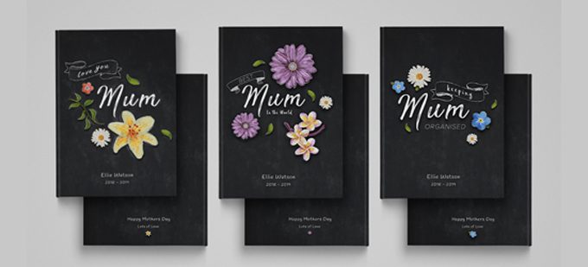

**Pricing and Availability**

TOAD® products can be purchased at any time of year from [www.toaddiaries.co.uk](http://www.toaddiaries.co.uk)

Pricing starts at £11.75 for a custom diary product, £8.95 for notebooks.

**-ENDS-**

**Notes to Editors**

**About TOAD®.**

TOAD®, standing for Today Or Any Day, are the leading innovators in their market, offering highly customisable and personalised products to a growing customer base.  TOAD® aims to be the place of choice for customised diaries, journals, planners and notebooks, and to continue to broaden choice, based on customer demand.

TOAD® Diaries is headquartered in Brighouse, West Yorkshire, fulfilling their orders directly through their on-site book binding factory.