FOR IMMEDIATE RELEASE

**"HAPPYAGONY" by Actor and Film Producer Mem Ferda tops Amazon’s Hot New Releases.**

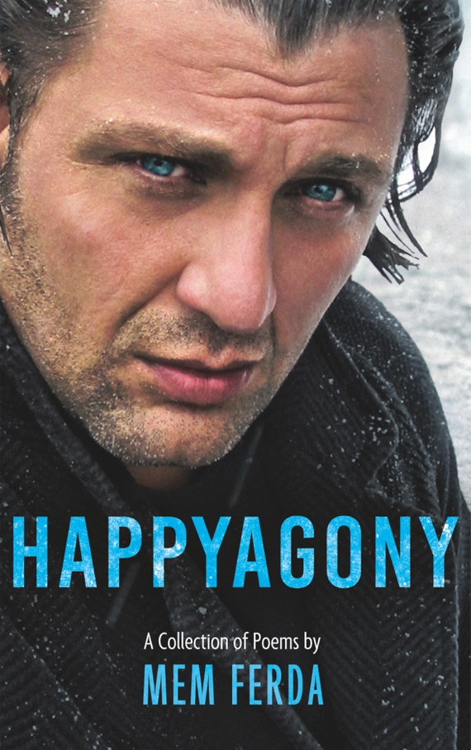

Esteemed British Actor and acclaimed Film Producer Mem Ferda takes a profound step into the literary world by releasing his first poetry anthology, *HAPPYAGONY* – A Collection of Poems by Mem Ferda.

Known for his captivating performances in films like *Pusher, Revolver* and *The Devil's Double*, Ferda now channels his artistic expression into a new medium, unveiling a collection that explores the essence of human experience with unfiltered emotion and insights.

Drawing from a tumultuous life filled with dramatic extremes, Ferda’s poetry touches on universal themes such as youth, love, grief, society, and wealth. The anthology emerged from Ferda's recovery journey after a life-altering accident in 2023, offering readers a window into his profound reflections and emotions.

*HAPPYAGONY* promises to engage readers with its range of feelings, from raw and gritty to inspiring and vivid, reflecting the intensity of the actor’s experiences. The collection comprises fifty poems accompanied by beautiful illustrations, each a testament to Ferda's journey toward healing and his embrace of poetry as a form of catharsis.

Mem Ferda’s life story, marked by vivid highs and profound lows, enriches his poetry, making *HAPPYAGONY* more than just a poetry book—it’s an intimate look at a man who has continually transformed personal adversity into creative expression.

*HAPPYAGONY* – A Collection of Poems by Mem Ferda is now available on [Amazon](https://amzn.to/4fBZmn1) in Paperback, Hardback, Kindle and Audiobook. In its first week of release, it shot to Number One position in Amazon's Hot New Releases. It is also available worldwide at Major bookstores, i.e. [Waterstones](https://www.waterstones.com/book/happyagony-a-collection-of-poems-by-mem-ferda/mem-ferda/9781836280392), [WHSmith](https://www.whsmith.co.uk/Product/Mem-Ferda/HAPPYAGONY---A-Collection-of-Poems-by-Mem-Ferda/15450532), [Foyles](https://www.foyles.co.uk/book/happyagony-a-collection-of-poems-by-mem-ferda/mem-ferda/9781836280392), and [Barnes & Noble](https://www.barnesandnoble.com/w/happyagony-a-collection-of-poems-by-mem-ferda-mem-ferda/1146581725?ean=2940193693406). Join Mem Ferda in celebrating the launch and experience the power of his words, forged in the depths of personal agony and the heights of pure happiness.

﻿Immerse yourself in the evocative verses of Mem Ferda’s latest poetry collection, HAPPYAGONY. Visit his website [HappyAgony.com](https://www.happyagony.com)[.](https://www.happyagony.com/) to explore his biography and learn about the sources of inspiration that shaped this remarkable work.

For any inquiries regarding arranging an interview or appearance with Mem, please email: info@happyagony.com

FOR IMMEDIATE RELEASE

**Critical Acclaim:**

* "A heartfelt collection that offers a meaningful cathartic reading experience. The pages bleed with feeling," praises **Independent Book Review**.
* **Readers’ Favorite** describes it as "an exceptional and thoughtful collection of modern poetry. Very highly recommended."
* **Kirkus Reviews** highlights it as "an enterprising anthology exploring many facets of the human experience."
* **Literary Titan** calls it "an emotional rollercoaster, perfect for anyone who enjoys introspective poetry and isn’t afraid to explore vulnerability and complex feelings."
* " A unique autobiographical insight that feels more intimate than a memoir. A worthwhile read for poetry fans." **Lovereading**

# About the Author

Mem Ferda is a celebrated British actor, award-winning film producer, and now, a poet whose multifaceted creativity has resonated through an extensive career in film and television. Born in South-West London to a Turkish diplomat father and a polyglot mother, Ferda’s passion for the arts was ignited at a young age. He holds a BSc Psychology Honours degree, an MBA, and a Postgraduate Degree in Classical Acting from the prestigious London Academy of Music and Dramatic Art (LAMDA), further honed by studies at the Royal Academy of Dramatic Art (RADA).

With over 200 film and TV credits, Ferda has portrayed a range of both heroic and villainous characters, sharing the screen with Hollywood icons such as Ray Liotta, Idris Elba, and Dominic Cooper. His performances are marked by a rugged charisma and an authentic presence, influenced by a life as colorful and dramatic as the characters he portrays. Beyond the screen, Ferda is a dedicated philanthropist who actively supports various international charities.

After a severe accident in 2023, Mem unveiled his poetic talent with the publication of *HAPPYAGONY*, a collection of poems that showcases his literary skill and offers a glimpse into his personal healing journey. Drawing from the highs and lows of his dynamic life, Ferda's work in poetry is as compelling and impactful as his acting, inviting readers to explore the depths of human emotion and resilience.

# Contact Information

Name: Mem Ferda

Email: info@happyagony.com

Country: UK

Website: <https://www.happyagony.com/>

END