Opportunity to bloom for budding horticulturalists
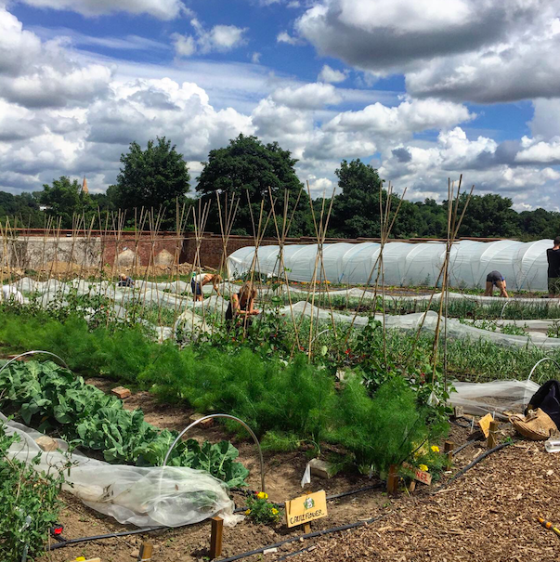
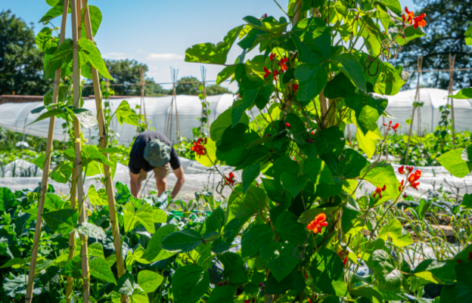
- Washing pots for community Grow Kits
- Harvesting in the garden
- Working in the garden
Hi res Images and image credits available here(please credit photographer, Ann Chown)

Four young horticulturalists are being offered an opportunity to sow the seeds of a career in gardening and agriculture.

Thanks to the Kickstart scheme from the Department of Work and Pensions, Hands of Hope Charity has four paid trainee grower positions available for 16-24 year-olds who are currently unemployed and claiming Universal Credit.

The jobs are based at the Charity’s Walled Kitchen Garden in Hawkhurst, West Kent. The new employees will become part of a small team developing a heritage walled kitchen garden and 22 acres of land in an Area of Outstanding Natural Beauty. ‘It’s an exciting time to be joining Hands of Hope, which is developing quickly and expecting a bumper organic harvest in the market garden this year’, says Hands of Hope Education Lead, Matthew Hill.

The Kickstart employees will be paid to work 25 hours per week for a six-month contract, on projects that tackle food poverty and rural isolation, helping improve physical and mental health in communities in Rother, Hastings and West Kent.

‘This is a great opportunity to start a career in Market Gardening, says Matthew. ‘It combines working outdoors in a beautiful setting with gaining valuable skills in growing, administration and charity work. The young employees gain skills in teamworking, problem solving, decision making, taking responsibility, nutrition, health and of course horticulture.’

The new employees will work with Hands of Hope’s growing and education teams, getting involved in all aspects of organic fruit and vegetable production, improving productivity at the garden and helping ensure its long-term success.
Says Matthew, ‘We want to develop skilled organic growers and these positions would ideally suit people who have considered this as a possible career path. The ideal candidates will be practical, flexible, motivated and love working outside in and with the natural environment.

The Kickstart Scheme covers 100% of the National Minimum Wage, at 25 hours a week for a total of 6 months. It offers paid job placements for 16-24 year-olds at risk of long-term unemployment. The placements are designed to provide experience, knowledge, and skills of being in a work environment and improve the chances of finding future long-term employment.
To be hired on the Kickstart Scheme, candidates must be 16-24, be ready for work, and be claiming Universal Credit.
If you or someone you know ticks these boxes and can travel to Hawkhurst in Kent, apply as soon as possible. Visit kickstart.connect.adecco.co.uk/, contact your local Job Centre or speak to your work coach and ask to be referred for Trainee Grower – Future Growers Project at Hands of Hope Charity. You can also contact info@hocharity.co.uk for more information.

----Ends----
For more information contact Mandy Doran, Trustee, info@hohcharity.co.uk
Add phone number
https://www.hohcharity.co.uk/
Images and image credits available here (please credit photographer, Ann Chown)

