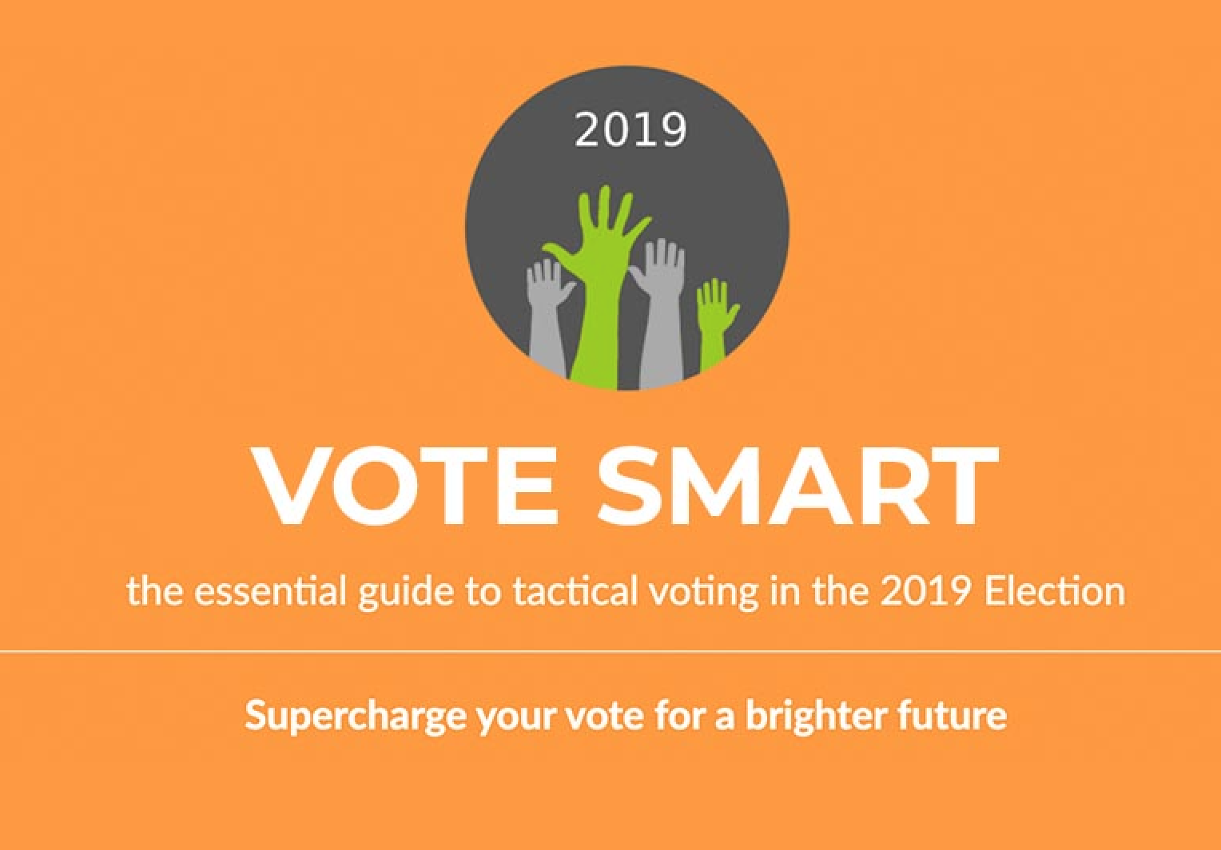
- PRESS RELEASE FOR IMMEDIATE RELEASE
Date 9 December 2019

- Surge in Tactical Voting Enquiries Reveals Hidden Volatility in Thursday’s Election – says voting advice group.
- With the General Election only two days away, and millions of voters still undecided, there’s been a sharp increase in people seeking tactical voting advice, and especially in constituencies where majorities hang by a thread, says tactical voting aggregator site, VoteSmart 2019.
- “The level of interest in our tactical voting advice suggests a potentially seismic shift in voting intentions that we think is not being picked up elsewhere,” explains Rob Miller, technology expert at tactical voting aggregator site, VoteSmart 2019. “Since launching our tactical voting ad campaign just three days ago, our ads have reached nearly 400,000 people, with 70,000 constituency and postcode searches on our website, and that’s currently going up by around an astonishing 1,300 searches an hour,” Miller adds, “add the fact that, while our site is national, our ad campaign, crowd funded by donations from around the country, focuses on just 33 constituencies where we believe tactical voting can have the greatest impact, then it’s clear that the power of the tactical vote is really coming home to people,” Miller says.
The statistics from VoteSmart 2019 have revealed another behaviour the team says they say they did not predict.
“The second surprise has been that voters are not just looking up their own constituencies, but most are also seeking advice on other seats too,” explains Richard Tunnicliffe, Co-Director of Represent Us, “so far we’ve had 40,000 unique visitors who have carried out 70,000 constituency searches between them. This strongly suggests many are also looking for advice on behalf of friends and relatives. What’s more, 75% of those who provided us with an indication of their voting intentions have pledged to follow the advice we’re giving. This is well beyond our expectations, and not only illustrates that voters are perceiving us to be a trusted source, but also that high numbers are committed to voting tactically,” Tunnicliffe concludes.
Tactical voting had a significant impact on the political landscape in 2017, with over 6 million people casting their vote tactically.
“Tactical voting has really burst onto the UK’s political scene in the last few years,” says Sue Ellar, VoteSmart Project Manager, “in 2017, a mere 75 votes stood between Theresa May and a working majority. That figure stopped me in my tracks when I first heard it because, with their votes, those 75 people forced May to accept scrutiny from parliament on everything, from her exit deal with the EU to her domestic agenda, and bolstered parliament’s ability to hold the government to account. We believe a surge in tactical voting on Thursday can once more stop the Conservatives railroading their policies through parliament, by denying the party a majority,” Ellar adds.
VoteSmart 2019 was set up during the last election in 2017 in response to conflicting tactical voting advice, which the team behind the campaign believed had the potential to undermine the impact of tactical voting advice.
“With VoteSmart, we set up a site that presented voters with clear facts,” explains Sue Ellar, “where they simply pop in a postcode or constituency to compare the advice from all the main tactical voting sites, backed up by analysis from our own experts, giving voters the advice they need to draw their own conclusions. Above all, we wanted to help people avoid throwing away their vote,” Ellar says, “and we’re delighted that there’s so much interest in our site, because that means more and more voters are getting the tactical voting advice they need,” Ellar concludes.
NOTES FOR EDITORS

1 For all press enquiries please email press@representus.uk

2 Represent Us is a non-party organisation set up in 2016 to support the tradition of British parliamentary democracy during the Brexit process. Our aim is to ensure Parliament retains control during this time, and that decisions of national importance are voted on, in full transparency, by our elected representatives from all parties.

In 2017 we campaigned for a meaningful final vote by Parliament on the UK’s exit terms from the European Union. We contributed to making this one of two issues on which significant rebellions took place in both Houses of Parliament.

We work with members of all parties, and with organisations which share our goals.
http://representus.uk/

3 VoteSmart 2019 is a tactical voting aggregator, originally established for the last election in 2017 and updated for the changed political landscape of 2019.

It works by providing an overview of all tactical voting sites giving advice in the general election on 12 December 2019. It aims to maximise the impact of tactical voting by giving voters the full facts in each constituency, with up-to-the-minute analysis, and sharing information with the main tactical voting sites. VoteSmart’s technical team has identified key constituencies where the tactical vote could change the course of UK politics in this most-significant general election.

4. The five tactical voting sites included in the VoteSmart tactical voting overview are:
Best for Britain’s ‘Get Voting’
People’s Vote
Remain United
Tactical.vote
Tacticalvote.co.uk
VoteSmart also includes voting advice from Unite to Remain and More United
ENDS

