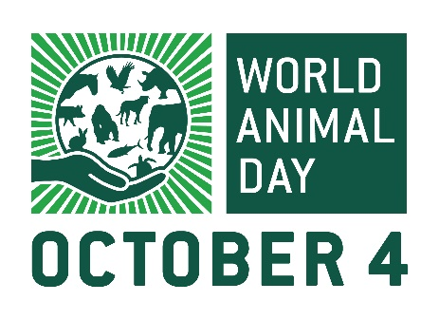
PRESS RELEASE

Date: 21st September 2023
FOR IMMEDIATE RELEASE

World Animal Day children’s design competition: winner announced
The winner of a World Animal Day 2023 children’s mug design competition has been announced, following a hugely successful event that saw entries from countries around the globe, including Turkey and Sri Lanka.
Ahead of the annual celebration of animals on October 4, young people across the world were invited to take part in an art contest to mark World Animal Day – the only day of the year that recognises all animals. Entries featured a wide variety of species including wildlife, insects, birds, marine animals and pets.
The winning design was created by 14-year-old Ruby from Oxfordshire in England, who submitted a beautifully colourful hedgehog holding a heart-shaped planet. The illustration will feature on a mug sold by Naturewatch Foundation, the UK-based animal welfare charity that coordinates World Animal Day.
Every year, hundreds of events are organised on, and around October 4 to raise awareness of animal welfare issues or fundraise for animal charities. Participants include schools, veterinary practices, community groups, animal welfare organisations and individuals who motivate their family and friends to also get involved. Since the first World Animal Day was held in 1925, events have become increasingly creative and now range from drive-through church blessings for animals to spay-a-thons for cats and dogs to abseiling down cliffs.
Sarah Carr, CEO of Naturewatch Foundation and coordinator of World Animal Day, said: “We were amazed to receive three times the number of entries to our mug design competition this year! Children in age categories from five to 17+ sent us wonderful drawings showing their love of animals – it was so difficult to choose a winner, but Ruby’s hedgehog will be perfect for our 2023 commemorative mug.
“The competition is just a small part of our phenomenal World Animal Day celebrations though. There are countless ways in which everyone who cares about animals can still get involved, including on social media – World Animal Day reaches over 50 million people online on October 4! We aim to raise awareness of the plight of animals and encourage people to do something to help make the world a better place for them. It’s a day for everyone to speak up for the voiceless, regardless of nationality, religion, faith or political ideology. If you want to be part of the biggest annual day for animals, visit the website today!”
For more information, and to get involved, go to worldanimalday.org.uk
----- END -----

NOTES FOR EDITORS

ABOUT WORLD ANIMAL DAY:
World Animal Day is coordinated every year by Naturewatch Foundation, an animal welfare charity in Cheltenham, Gloucestershire.
October 4 is an opportunity for individuals, businesses, community groups, universities, schools and other groups to raise funds or awareness for their favourite animal charity.
World Animal Day has grown steadily in popularity since 1925, when the first celebration was held in Germany. Every year around October 4, World Animal Day reaches over 50 million people online.
The movement embraces all animals and the unique concerns of each, in every country, and makes animals front-page news. Through increased awareness and education, a compassionate culture will be developed, which feeds into legal reform and social progress to make this world a fairer place for all living creatures.
World Animal Day has over 90 voluntary Ambassadors in 70+ countries. Their role is to:
• Create awareness of the World Animal Day movement in their country.
• Encourage individuals and groups to organise events every year.

ABOUT NATUREWATCH FOUNDATION:
Naturewatch Foundation is a registered charity that has been speaking out on behalf of animals since 1991 by:
• Campaigning peacefully against animal abuse
• Lobbying to improve animal protection legislation
• Raising awareness through education
• Supporting the World Animal Day movement to raise the status of animals around the globe
naturewatch.org
49 Rodney Road, Cheltenham, Gloucestershire GL50 1HX

FOR FURTHER INFORMATION OR INTERVIEWS, PLEASE CONTACT:

Sarah Carr
Coordinator, World Animal Day HQ / CEO, Naturewatch Foundation
+44 (0)1242 252871
sarah@worldanimalday.org.uk

Claire Brazington
Communications Coordinator, World Animal Day HQ / Naturewatch Foundation
+44 (0)1242 252871
claire@worldanimalday.org.uk

