HOW A YOUTH-LED CHARITY IS REDEFINING HOUSING FOR FORCIBLY DISPLACED FAMILIES IN MALAWI

Traditionally victims of displacement take years to get a secure home of their own. A partnership between Nostos Homes and Habitat for Humanity in Malawi is challenging this status quo by building a community of modular homes in less than a week.

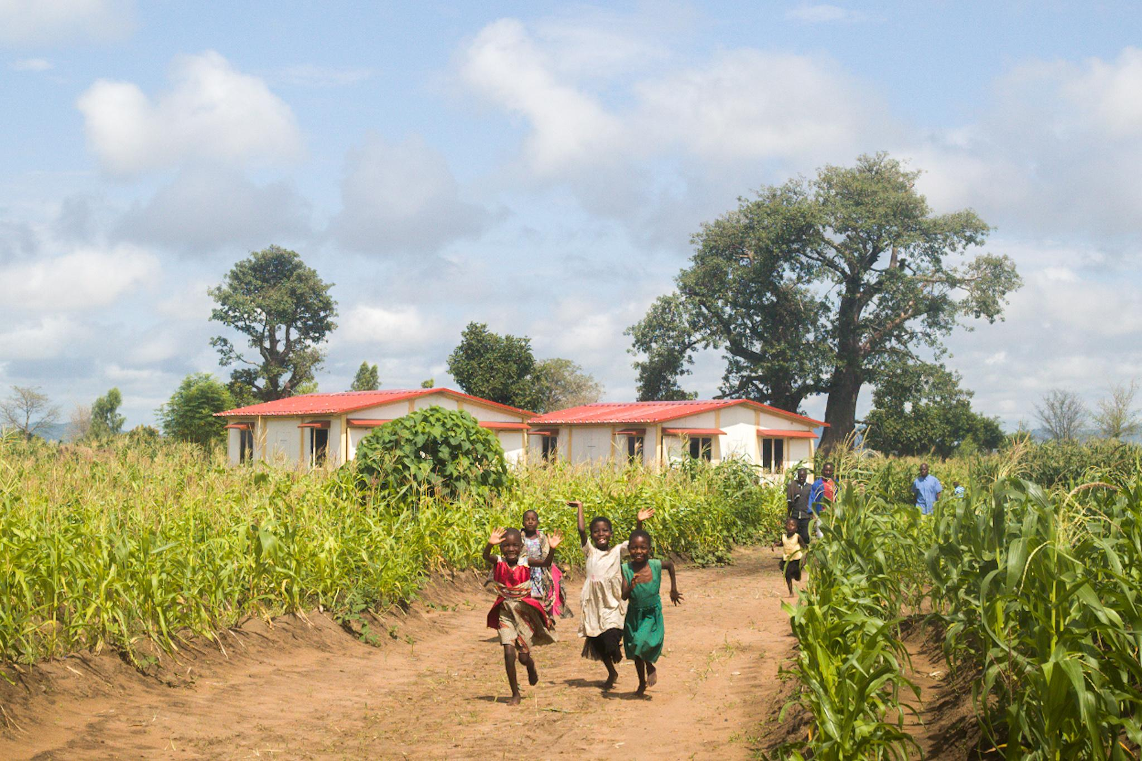
The homes have brought hope and laughter back to Phalombe, Malawi, an area ravaged by cyclone Gombe. Children run and wave outside the Nostos community that has provided their families with 350,000 nights of shelter.

Ethel Chamba, 35, is a single mother of three living in Mwango, a village in rural Malawi. She depends on piecework jobs and subsistence farming to earn a livelihood. Last year, while she was struggling to make ends meet after her recent divorce, Cyclone Gombe hit her village, completely destroying her home and changing her life overnight. Being a mother of a child with a chronic illness and living below the poverty line meant that it was impossible for her to find funds to reconstruct her home. Since then, Ethel and her children have been forced to live in their grandmother’s house.

But this changed last month when a partnership between Nostos Homes, a youth-led UK charity, and Habitat for Humanity, the world’s largest not-for-profit builder, built a community of innovative modular homes in Phalombe, Malawi. Ethel and her family have now moved into their brand new Nostos home, made using mild steel frames and insulated PUF panels to ensure durability, wind resistance, and a 20 year lifespan. The Nostos home design achieves all of this in less than half the cost of a traditional brick and mortar house of a similar lifespan. Perhaps what is most innovative about this home though is that it was built in under a day.

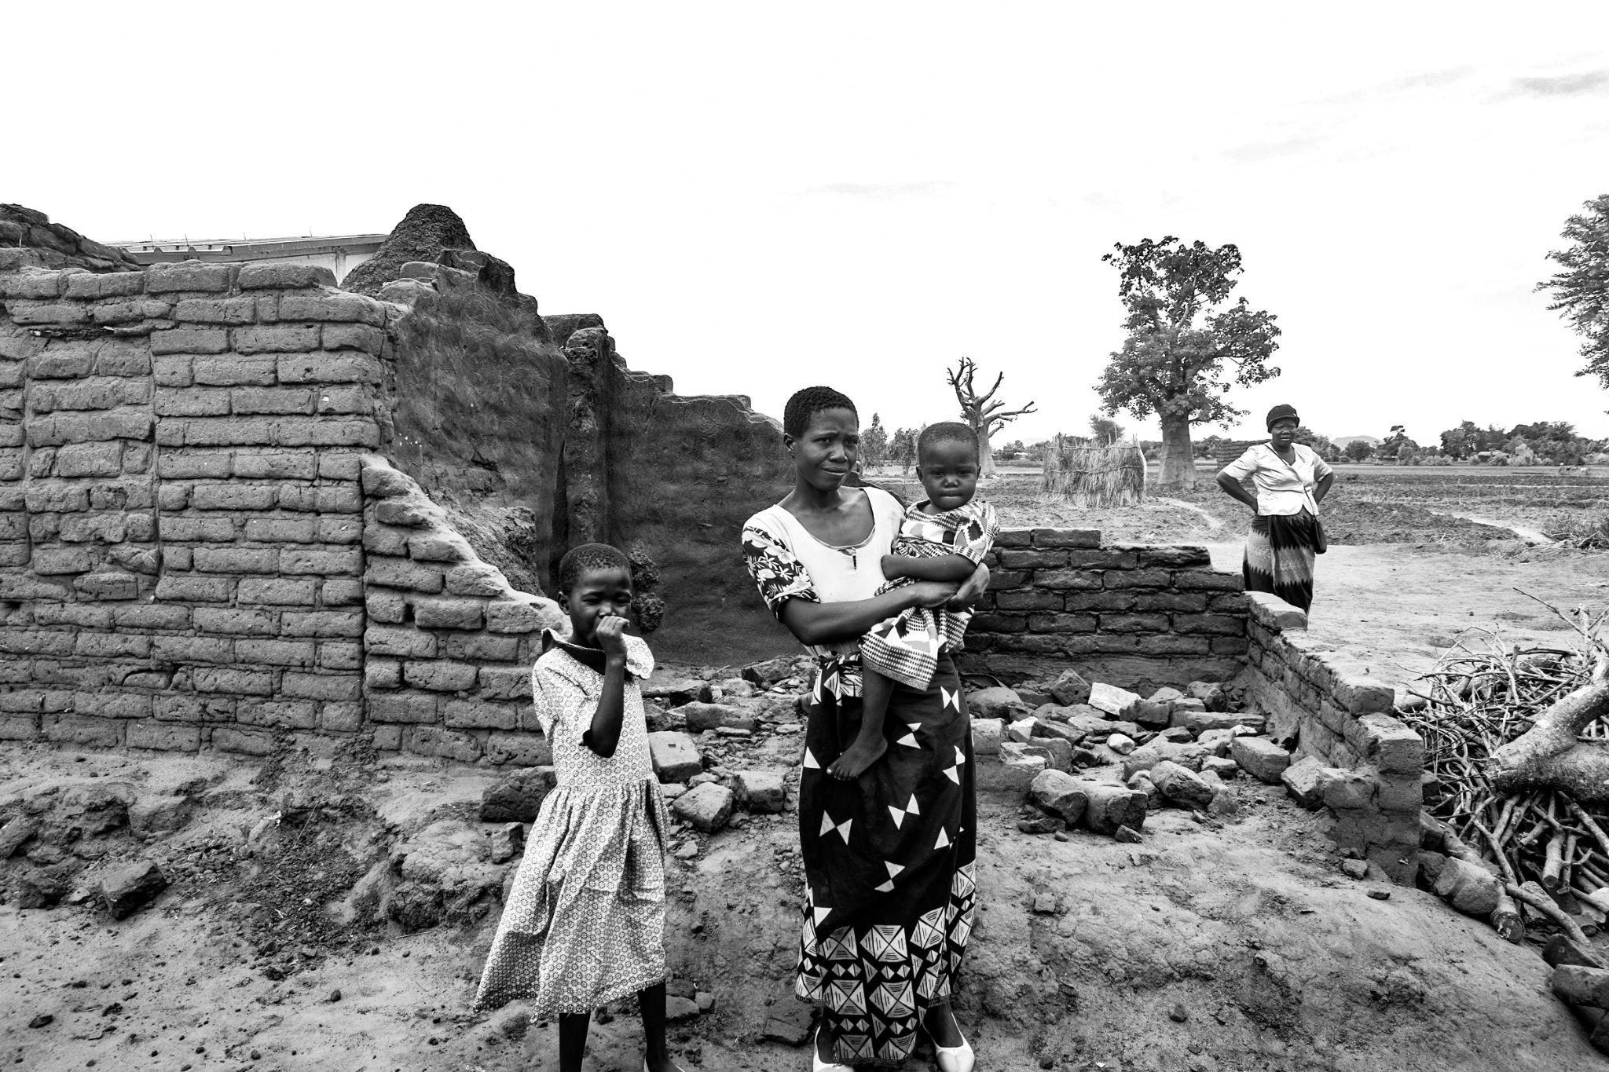
Ethel Chamba’s old home was left in ruins after Cyclone Gombe hit her village in Phalombe, Malawi, drastically changing her life overnight.

Madhav Datt, Chairman of Nostos, says “It is inspiring to see displaced families in Malawi use Nostos Homes as a mechanism to rebuild their lives. The Nostos model lets us build homes in traditionally inaccessible areas where brick and mortar construction is impossible, allowing us to reach some of the most vulnerable and hard to reach communities around the world.”

These Nostos homes are modular and follow a prefabricated mode of construction. This means that all the parts, or modules, of the home are manufactured separately and then assembled at site. Think of it like a life-sized Lego set - each component plays a critical role and has been carefully designed to allow easy transportation in the disassembled form in a truck; and quick assembly, under a week for a community of 8 houses, at the deployment site after a disaster. Nostos has partnered with Modulus Homes, an innovative prefab start-up in India to manufacture the homes in their factory.

These modular homes are largely location agnostic and can be deployed for forcibly displaced communities across the world. Infact, Nostos was born from a concept conceived by Kaushal Shetty, CEO of Nostos Homes, while he was in university studying architecture, as a solution to the displacement he witnessed every monsoon near his childhood home in Udupi, India. Kaushal says, “I realised that losing your home has negative ripple effects on the family’s livelihood, health, and education. It became clear to me that in order to sustainably break this cyclical pattern of displacement, families had to be given strong climate resistant homes quickly after a disaster”.

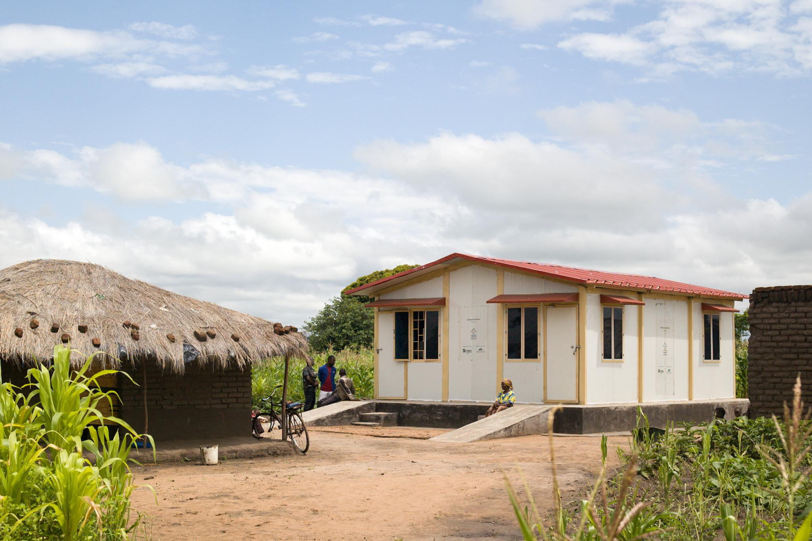
The Nostos' homes were brought in a disassembled stage to Phalombe in a truck. The entire Nostos community was built up in less than a week next to the families’ old homes.

Nostos is entirely led by young people and funded by corporate philanthropy from companies such as Goldman Sachs and Mastercard. Nostos co-founders Datt and Shetty have both been named to Forbes 30 Under 30 lists, and have gained international acclaim from HRH Prince William and the World Bank for their impact.

While the fundamentals of the home are the same irrespective of location, the design allows for easy customisations. For instance, the houses in Malawi were built on a raised platform to avoid flooding in the rains. Habitat for Humanity Malawi National Director, Anock Kapira says “In our pursuit of contributing to the alleviation of housing poverty in Malawi, exploring innovative solutions is a priority for us. We are enthusiastic to partner to bring Nostos Homes to Malawi and provide these new climate-proof and disaster-resilient homes to the most vulnerable families.”

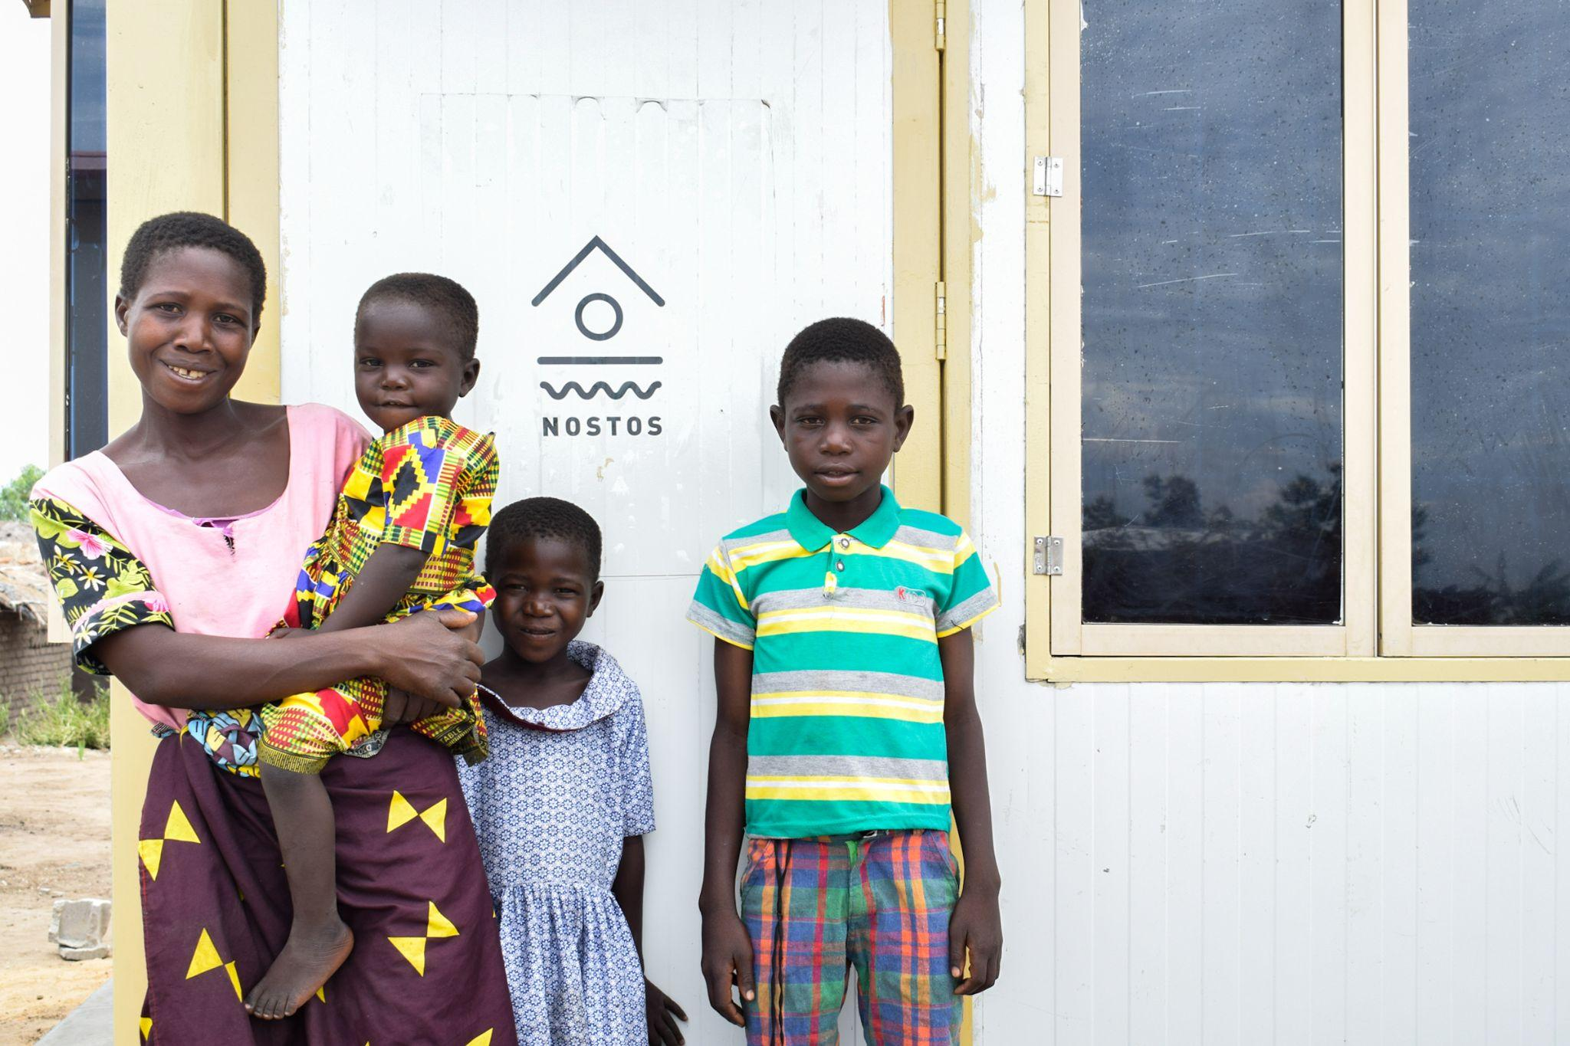
Ethel and her children have moved into their new home. She finally has a safe, private space to raise her three young children in. She finally has an opportunity to rebuild her life.

The Nostos community in Malawi will provide more than 350,000 nights of shelter to families like Ethel’s. Devika Narayanan, Chief of Staff of Nostos, says “These are families that are facing extremely difficult situations - for instance, many of them are single woman headed households with children living with HIV. For them, a Nostos Home is more than just a roof over their heads. It means fewer doctor visits due to better protection and sanitation, faster return to jobs and schools, and lesser harassment.”

Ethel told the Habitat for Humanity Malawi officials, “Having a home of my own now allows me to once again believe that life can get better. My children can finally have some peace in their lives.”

This partnership project received extensive support from the Malawi Government. Peter Chimangeni, Director at the Department of Disaster Management Affairs, Government of Malawi said “We are deeply appreciative of the life-changing work that Habitat for Humanity and Nostos have done for people who lost their homes in the devastation caused by Cyclone Gombe. We offer our full support in providing many more Nostos homes to displaced families in Malawi.”

