

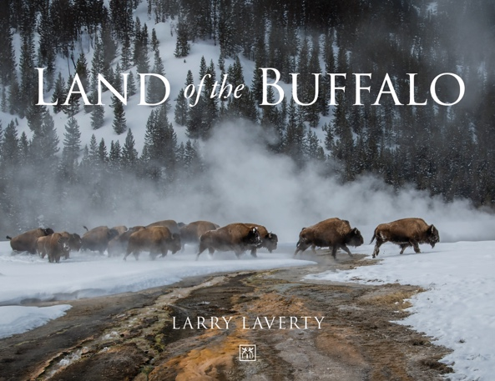 | Title: Land of the Buffalo  Author: Larry Laverty  ISBN: 9791917391894  Format: Hardcover.  Priced: £29.99  Publication date: 23rd July 2026

THE STORY OF THE AMERICAN BUFFALO IN WORDS AND PHOTOGRAPHS
American Buffalo Continue to Face Threats from Humanity
Just 150 years ago, the wild American buffalo was nearly wiped off the face of the earth. The destruction was justified, some said at the time, in order to pave the way for national destiny. Roughly 60 million buffalo died, and they continue to die today. In Land of the Buffalo, acclaimed wildlife photographer and writer Larry Laverty documents in words and photographs the lives of these magnificent creatures who embody the character of Yellowstone Park and the United States.
Through their will to survive a harsh and unforgiving world and their raw physical strength, buffalo came to epitomise the strength required of early Americans to forge their country. But the very people who carved this nation out of wilderness are the very ones who destroyed almost every last living buffalo in the process. “Like the bald eagle, the American buffalo is a powerful symbol of the United States. Yet while the buffalo may represent national qualities of strength and resilience, it’s incumbent to remember that the American buffalo, like the American Indian, were here first. This was their land, their home, and we destroyed it,” says Laverty.
With over 150 beautiful photographs taken by Laverty, Land of the Buffalo captures the natural beauty of the buffalo and its habitat in Yellowstone throughout the year. In winter, as they endure sub-freezing temperatures and meagre food sources dwindle, life becomes more desperate. Spring is Yellowstone’s annual renewal, as the dormant and barren landscape comes to life with new growth. In summer, most of the population indulges in the mating season, known as the rut. In autumn, as days grow shorter and colder, the veterans of last winter brace themselves for the challenges ahead.
In keeping with its management plan, the park is required to limit the buffalo population to between 3,500 and 6,000. To accomplish this, park management uses three tools: tribal and state hunting as the buffalo migrate out of the park, trapping and shipping buffalo to slaughter with the meat and hides offered to tribes, and the Bison Conservation Transfer Programme. The Stephens Creek Bison Capture Facility, located in northern Yellowstone National Park, is the primary facility for capturing and managing wild bison. The facility has been a target of criticism from environmental groups, such as the Buffalo Field Campaign, which advocate for the freedom of the herd and have raised concerns about transparency and the slaughter of wild animals.
With Laverty’s photographs accompanying the history of the buffalo and its current status in Yellowstone National Park, Land of the Buffalo enlightens readers about the legacy of these magnificent shaggy animals, their environs, and the controversial life that buffalo face today.

THE STORY OF THE AMERICAN BUFFALO IN WORDS AND PHOTOGRAPHS

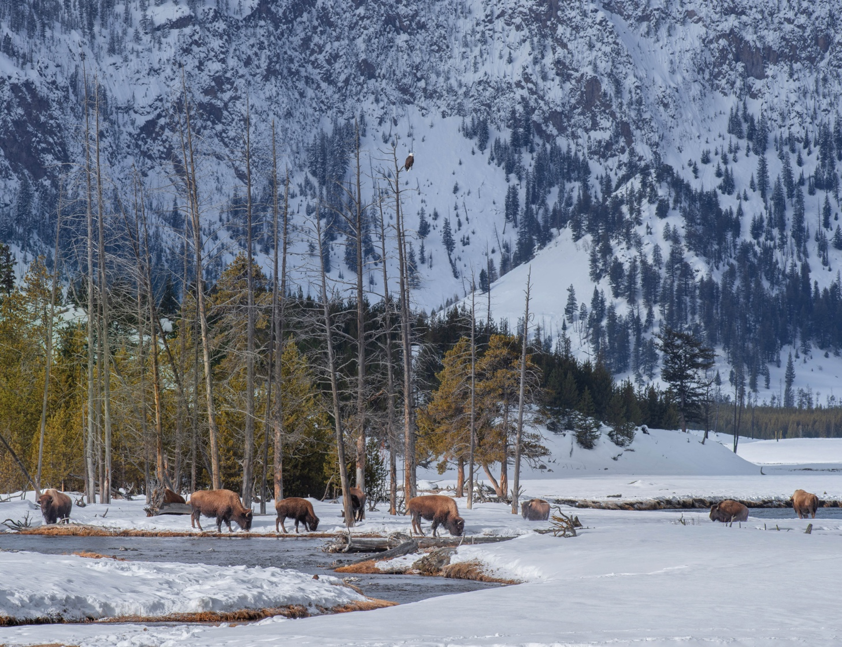

More Follows

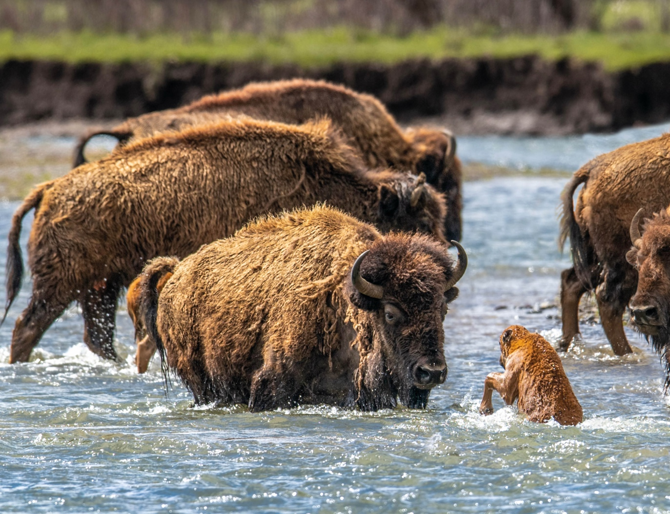

ENDS
Notes to editors:
- For all media enquiries and image requests, please contact Simon Wooldridge E: simon.wooldridge@lidbusinessmedia.com; Mobile: +44 (0) 7879148420.
- To find out more about LID Publishing please visit: https://lidpublishing.com/
- About the author: Writer and photographer Larry Laverty has lived an unorthodox life. Exposed to writing, photography and wildlife at an early age by his parents, he chose to live the career of a Hollywood actor for 30 years before returning to his roots.
His attraction back to wildlife was, though, much different to those early days of childhood innocence when he was drawn to the magic of birds and butterflies. This time it came from a sense of loss, of injustice, as human beings persist in their destruction of all things wild. Among the first wild beings to capture his attention were the buffalo of Yellowstone National Park. This book is the culmination of over seven years of documenting their lives and involves observations of over 50 years.
Laverty has published two other books, Power and Majesty (2019) and Magnetic (2025), both documenting the lives of elephants.
He is a proud member of the Explorer’s Club, the Wildlife Society, Voices for Asian Elephants, the National Eagle Scout Association, the Screen Actors Guild, Actors Equity Association, and the American Alpine Club. He continues to pursue his most unusual life from his home in Oakland, California.
For more information visit LarryLavertyWildlife.com

