[For Immediate Release]
Fintech, Suits Me, Passes 100,000 Users After a Year of Record Growth
The fintech alternative banking solution that provides accounts to the underbanked has surpassed the 100,000 accounts opened mark and over the last two years, has grown from just 30,000 to 100,000 account holders.
Suits Me was launched in 2015 when CEO, Matthew Sanders, realised that there were many individuals who had moved to the UK but were struggling to find a suitable banking solution to receive their wage as they had no proof of address.
Nowadays, the fintech solution doesn’t only provide accounts to migrant workers and expats but also to UK residents who have been unable to get on the banking ladder due to a poor or non-existent credit history, bankruptcy, IVA’s, or who were simply looking for an alternative to a mainstream bank.
In the last year, Suits Me saw growth of 229%, which is a testament to how the company are giving underbanked individuals access to personal banking and the ability to manage their money in a safe and efficient way.
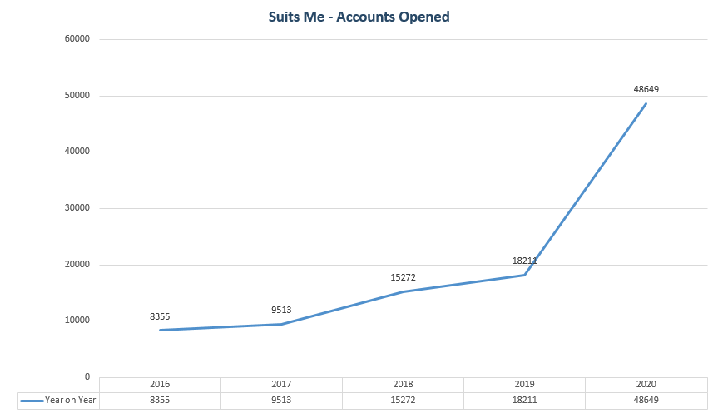
Matthew Sanders, Founder and CEO said: “Over the last few years, we’ve worked hard to remove the invisible barriers from the traditional banking system in order to provide financially excluded individuals with a suitable way to safely and efficiently manage their finances.
“I would like to thank the entire Suits Me team for all their outstanding hard work and unparalleled commitment over the last few years, which has been key in enabling us to reach this incredible milestone.”
In addition to reaching 100,000 accounts opened, there has been huge internal growth inside Suits Me – having gone from 10 staff members to 30 in just over a year, with plans to take on more staff in the near future.
Commenting on the growth of the company, Kim Roberts, Marketing and Communications Director, said: “Over the last 16 months we have focused heavily on a multitude of digital marketing channels in order to reach our target markets and help those who are financially excluded (or those looking for a secondary account).
“This year, we have also worked on improving our customer journey, making the onboarding process as simple and easy as possible. Our ambitious marketing strategy will continue to add more diversity and alternative options to the banking sector, allowing us to reach customers who are currently underbanked.”
One of the fundamental areas of the business which has experienced significant growth is Suits Me’s Customer Care Team. In 2018, there were just two full time employees handling all customer enquiries and now there are 22 members of the team.
John Oakley, Operations Director, explained: “At Suits Me, we strongly believe in ensuring that our customers can communicate with someone who speaks their own language so, over the year we’ve invested heavily in recruiting a multilingual team. We now offer seven different languages to our customers, as well as four more through our written communications, making it one of our USP’s.
“Our range of languages available has resulted in customers choosing our service and remaining to stay with us, year after year. This showcases how our customers feel reassured and confident in the service and products we offer them, as opposed to risking possible language barriers elsewhere.”
Looking towards the future, Suits Me has many projects on the horizon but one of the main targets is to reach 500,000 account holders by the end of 2021, building their customer base by 500%.
Richard Lynch, Managing Director, explained: “This profound achievement further extends the reach and ambition of the Suits Me brand as we continue to expand into new channels as part of our extensive growth strategy over the next few years.
“Going forward, we plan to meet the needs of even more of the UK next year, making it even easier to send and receive money with no credit history or UK address. I can confidently say the future is looking bright for Suits Me, so watch this space.”
Snapshot of an Average Suits Me Account Holder
- Typically male (65% of account holders)
- Average age: 25-34
- Nationality: Romanian, followed by English, Bulgarian and Polish.
- Customer Values: Transparency, Honesty and Integrity
###

Notes to editor:
Link to Suits Me: suitsmecard.com

Contact
Kim Roberts
Marketing and Communications Director
kroberts@suitsmecard.com
07855503443

About Suits Me:
Suits Me are a hassle-free alternative to traditional banking, offering a current account with access to online banking, a mobile banking app and a contactless debit card. Suits Me was founded in 2015 to provide a current account to customers who may have poor or no credit history, no proof of address, or struggle to open an account with a traditional bank.

Currently operating in Cheshire, UK, Suits Me gives people an alternative solution to a high street bank. Suits Me do not perform credit checks and provides all their account holders with access to their exclusive cashback reward programme.

For more information, go to suitsmecard.com or follow us @suitsmecard on Facebook, Twitter, Instagram, and LinkedIn.

