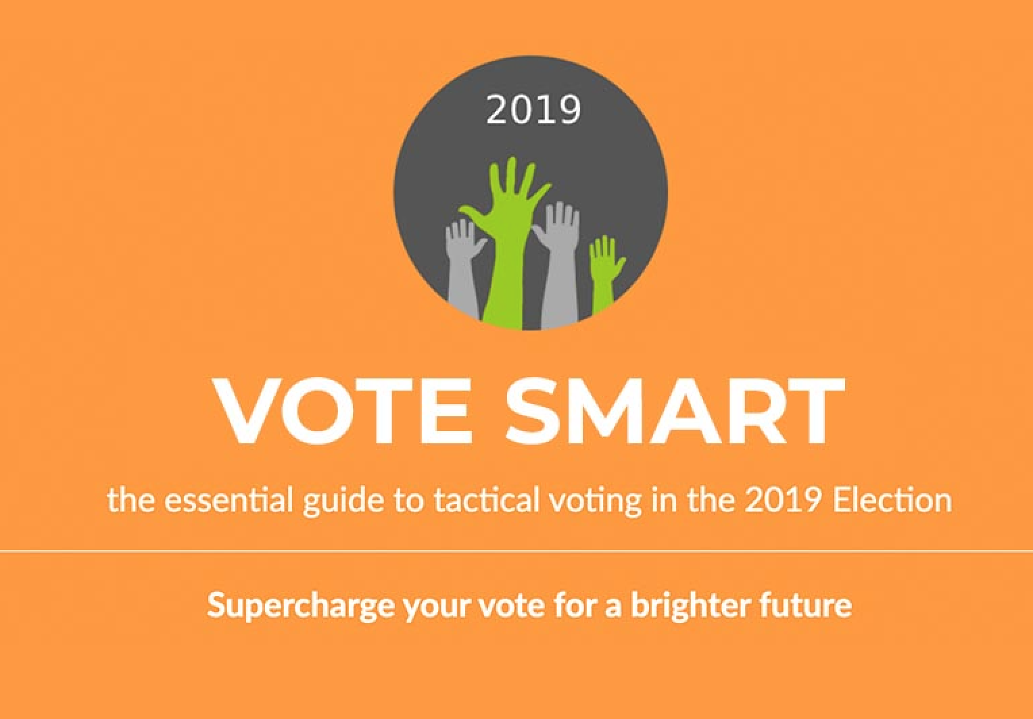
- PRESS RELEASE FOR IMMEDIATE RELEASE
Date 11 December 2019

- Tactical Vote 2019 – Last-Minute Changes Risk Undermining Tactical Voting Drive – warns voting advice group.
- With polling stations opening tomorrow, and last-minute changes to voting recommendations in 200 constituencies, voters are being urged to double check tactical voting advice before they go out and vote tomorrow, says tactical voting aggregator site, VoteSmart 2019.
- “Nearly a third of constituencies have seen changes to tactical voting recommendations in the last 48 hours,” says Richard Tunnicliffe, Co-Director of campaign group Represent Us, the team behind tactical voting aggregator VoteSmart 2019, “we’re updating the recommendations as they come in, but with this level of unpredictability it’s vital that voters check back with us at VoteSmart 2019 before they go out and vote, to be confident they’re on the same page as everyone else – it’s simple to do from a mobile or laptop. We have to avoid a single wasted tactical vote in this knife-edge election,” Richard Tunnicliffe adds.
While many constituencies show minimal movement, in those 200 hundred constituencies voting recommendations continue to change, and the VoteSmart team are flagging particular concern in 8 seats – Kensington, Broxtowe, Luton South, Finchley, Two Cities, North East Somerset, Eddisbury and York Outer – that are still in considerable flux.
“We know tactical voting could be the decider in this election,” says VoteSmart technology expert, Rob Miller, “we’re getting a peak of 4,000 visits an hour, and since launching just over a week ago, we’ve had over 123,000 constituency searches on our site, suggesting potentially seismic changes in voting intentions. This is well beyond our expectations, but tactical voting only works if everyone is following the same advice,” Miller adds.
Tactical voting is believed to have had a significant impact on the political landscape in 2017, with over 6 million people casting their vote tactically. Indications are that tactical voting will once more be decisive on Thursday.
“VoteSmart2019 has become a trusted source of advice in this most volatile election,” says Sue Ellar, Project Manager on VoteSmart, which launched at the last election in 2017 in direct response to widespread conflicting tactical voting advice, “our aggregator approach to voting recommendations has been endorsed this week by the Guardian newspaper, who wrote ‘the best starting point for the curious is votesmart2019.com’¹, and on top of that, 75% of those who have indicated their voting intentions on our site have pledged to follow the advice we’re giving. So the message is, if you are unsure, visit VoteSmart2019.com just before you go out to vote. Simply put in your postcode or constituency to find the most up-to-date voting recommendation where you live. We can’t afford for a single person to throw away their vote simply because they didn’t have the latest advice,” Sue Ellar concludes.
1 Endorsement for VoteSmart2019.com from the Guardian https://www.theguardian.com/politics/2019/dec/10/tactical-voting-across-the-uk-a-region-by-region-guide

NOTES FOR EDITORS

1 For all press enquiries please email press@representus.uk

2 Represent Us is a non-party organisation set up in 2016 to support the tradition of British parliamentary democracy during the Brexit process. Our aim is to ensure Parliament retains control during this time, and that decisions of national importance are voted on, in full transparency, by our elected representatives from all parties.

In 2017 we campaigned for a meaningful final vote by Parliament on the UK’s exit terms from the European Union. We contributed to making this one of two issues on which significant rebellions took place in both Houses of Parliament.

We work with members of all parties, and with organisations which share our goals.
http://representus.uk/

3 VoteSmart 2019 is a tactical voting aggregator, originally established for the last election in 2017 and updated for the changed political landscape of 2019.

It works by providing an overview of all tactical voting sites giving advice in the general election on 12 December 2019. It aims to maximise the impact of tactical voting by giving voters the full facts in each constituency, with up-to-the-minute analysis, and sharing information with the main tactical voting sites. VoteSmart’s technical team has identified key constituencies where the tactical vote could change the course of UK politics in this most-significant general election.

4. The five tactical voting sites included in the VoteSmart tactical voting overview are:
Best for Britain’s ‘Get Voting’
People’s Vote
Remain United
Tactical.vote
Tacticalvote.co.uk
VoteSmart also includes voting advice from Unite to Remain and More United
ENDS

