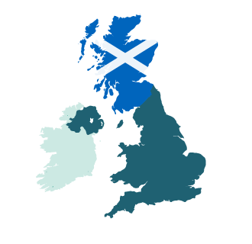
MARKETING ANALYSTS PREDICT A WIN FOR SCOTTISH INDEPENDENCE
UK: 10/05/2021
- Marketing psychology experts at Murray Dare predict a win for the “Yes” vote in a new long-form think piece titled “Why the IndyRef2 “Yes” Vote Will Win: A Marketing Psychology Perspective”.
- This analysis makes use of the latest research in marketing psychology to examine the campaign materials on both sides of the debate.
- The overwhelming SNP majority in the Scottish election means a second independence referendum is — in the words of Nicola Sturgeon — “when, not if”.
- People are hungry for analysis on this topic not just in Scotland but also in the rest of the British Isles and throughout the EU.
Quote
“The timeline is murky, but Scotland will gain independence one way or another. It’s a bold claim, we know, and yet you won’t find any polls or cultural observations in our analysis. We aren’t here to speculate on Scottish perceptions of Brexit, the handling of the pandemic, or any other socioeconomic circumstances that might have swayed the population towards voting for an independent Scotland. No, we want to talk about marketing psychology...”
About the Article
Murray Dare is an award-winning marketing consultancy that distills complicated marketing principles down to their bare bones. As content marketers, Murray Dare aren’t interested in pumping out advice on how to use the latest SEO tool. Trends change but human behaviour — and the driving forces behind it — are constant.

In this latest think piece, Murray Dare looks beyond Brexit to the next contentious issue facing the British Isles — Scottish independence. This analysis of the possible outcomes of IndyRef2 applies the principles of marketing psychology to both sides of the campaign.

Marketing psychology is an often-overlooked yet crucial framework with which to view the independence debate. Whether they are studying psephology (the study of voting trends) or online shopping habits, psychologists and behaviourists know the same trends apply.

This apolitical analysis ultimately draws the conclusion that Scotland will vote to leave the UK.

Disagreement and debate are welcomed. The intention of this article is simply to inform and empower the nation by revealing how marketing psychology affects all aspects of our lives.

Media Contact:
Holly Duhig e: holly@murraydare.co.uk / t: 07876764211

