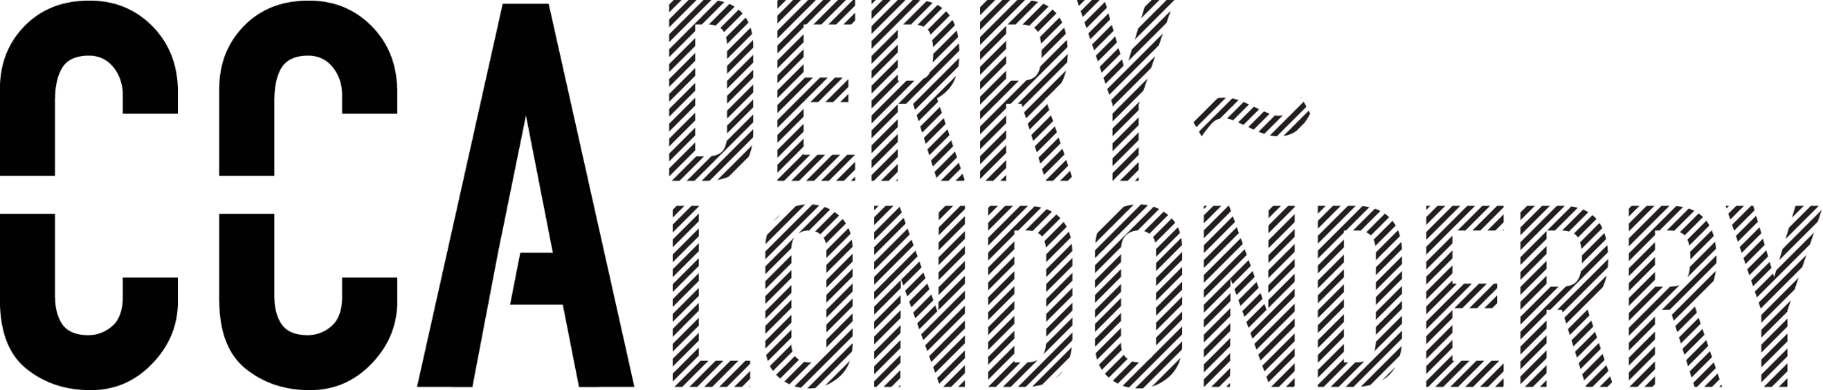 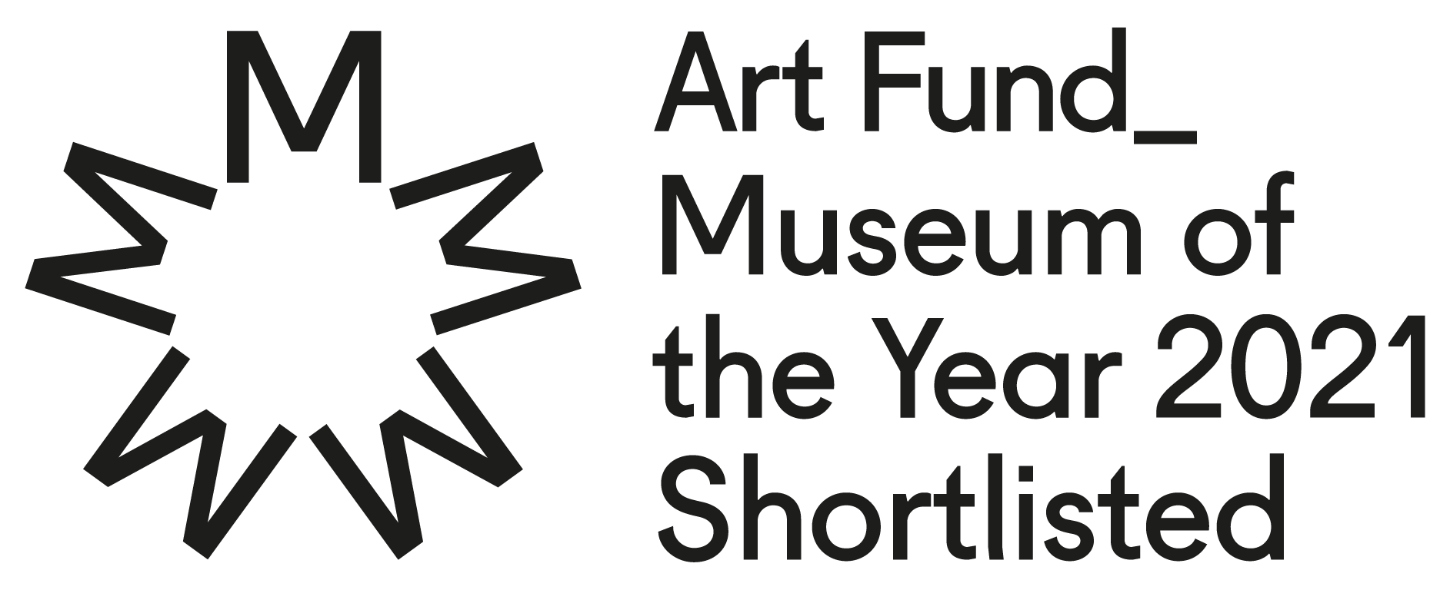

Press release

For immediate release: September 2025

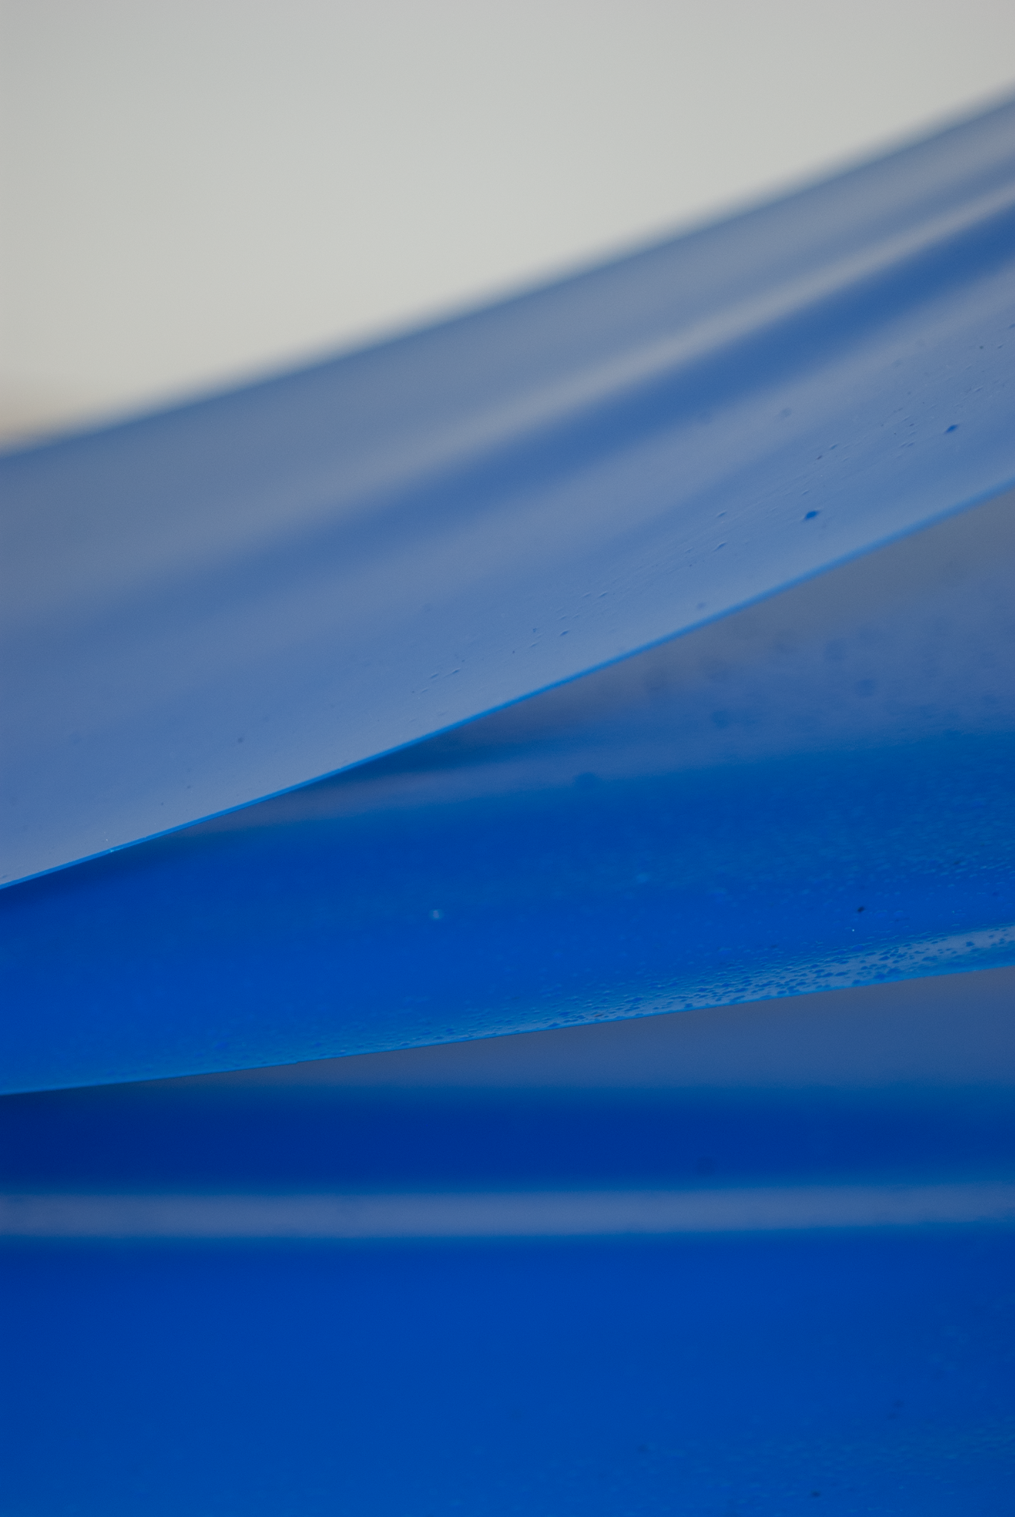

‘Dura’ Launches at CCA Derry~Londonderry, a new solo show by artist Ciarraí MacCormac

CCA Derry~Londonderry is delighted to announce its upcoming exhibition by artist Ciarraí MacCormac will launch at the gallery on 4 October 2025, 7–9pm.

*Dura* contains a new body of work comprising painting, sculpture and works on paper. The polyglot sensibility of paint is what keeps Ciarraí drawn to working with this material. The artist has applied her research into pristine preservations within bodies and operative techniques to give a new lease of life and longevity into her paintings. Within the works there is a layering of liveness and cross sections of surface to create a focus on imagined compartments within the body. The works are constructed from poly materials using primary colours of red, blue and yellow. Their peripheral shapes and use of repetitive accumulation aims to create a sense of dilution throughout the exhibition.

About the artist

Ciarraí MacCormac, born in Co Antrim N. Ireland. She currently lives and works in Belfast. Ciarraí is a Fine Art graduate from Bath School of Art and Design (2014) and she was the inaugural Freelands Studio Fellow for Belfast School of Art (2023-2024). Ciarraí has been the recipient of awards; BEEP Painting Biennial (2024) Shortlisted, AIR Open (2024) Shortlisted, British Contemporary Painting Prize (2024) Long-listed.  
ciarraimaccormac.com

ENDS

**Centre for Contemporary Art Derry~Londonderry**

10–12 Artillery Street, Derry~Londonderry, BT48 6RG, Northern Ireland

+44(0)2871 373538 | ccadld.org | info@ccadld.org

Opening times: Tuesday–Saturday noon–6pm. Free admission

**About CCA Derry~Londonderry:**  
The Centre for Contemporary Art (CCA) is a publicly funded space within the historic city walls of Derry~Londonderry. CCA creates opportunities for audiences to experience ambitious, experimental and engaging art and for emerging artists to develop successful careers. CCA fosters a wide range of artistic, curatorial and critical practices through five programme streams: research and production, exhibition- making, public programmes, publishing and residencies.

CCA was a Finalist in Art Fund Museum of the Year 2021, the largest museum prize in the world. CCA was recognised for its resilience and adaptability throughout the pandemic, and their continued effort to support audiences and artists including creating paid opportunities for artists and freelancers when they needed it most.

CCA is a member of Plus Tate: Plus Tate is a network, which comprises 35 cultural institutions – including the Tate galleries – that have strong artistic vision, a focus on contemporary art, outstanding public programming and a commitment to local community engagement through art. Plus Tate aims to support the development of the visual arts across the UK.

**Image courtesy Ciarraí MacCormac**

**For media enquiries:**   
Seán Ward, Marketing Coordinator for CCA Derry~Londonderry 10-12 Artillery Street, Derry~Londonderry, BT48 6RG, Northern Ireland   
sean@ccadld.org | +44(0)2871 373538 | @CCADLD

*Dura* at CCA Derry~Londonderry is supported by:

