Building Together: Co-creating with Local Communities
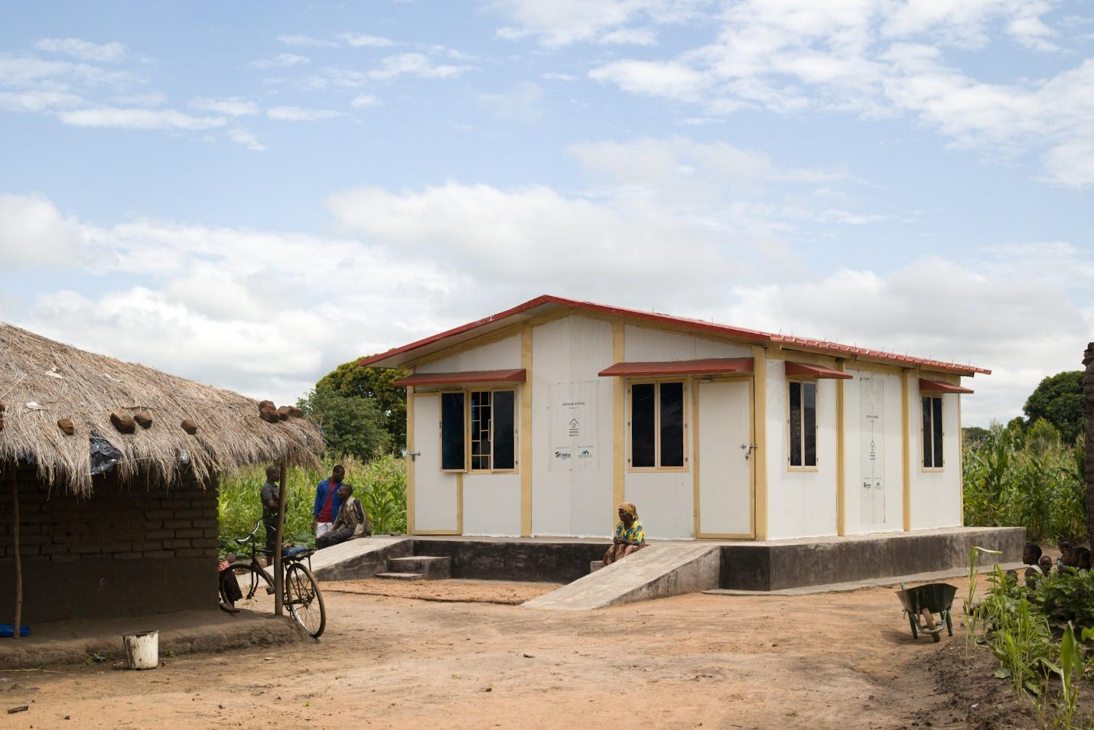
Author: Board of Trustees of Nostos Homes, Felix Chu
Photos taken by Chief Design Officer, Devanshu Bhardwaj
In recent years, Malawi has faced a series of challenges as it seeks to adapt to a rapidly changing world. One of the most significant of these challenges has been environmental sustainability.
Mudbricks are the primary and most commonly employed construction materials for houses in Malawi and in many developing countries, due to their low cost and easy availability. They are created by combining mud with a binding agent like rice husks or straw. Despite their widespread use and convenience, mudbricks come with a few drawbacks. They are prone to damage, particularly from rain and wind, and they are typically quite heavy, making the construction process physically demanding.
Another issue with mudbrick houses is that they can be highly polluting to the environment. The manufacturing process typically involves digging up soil, which can cause soil erosion and other environmental problems. Additionally, the production of mudbricks requires a lot of energy, often from burning wood or other biomass, which contribute heavily to deforestation and air pollution. In order to address these issues and promote environmental sustainability, the Malawi government has banned the use of fire-cured bricks in all construction projects since 2020, in part of a broader effort to promote sustainable building practices and reduce the environmental impact of construction in the country.
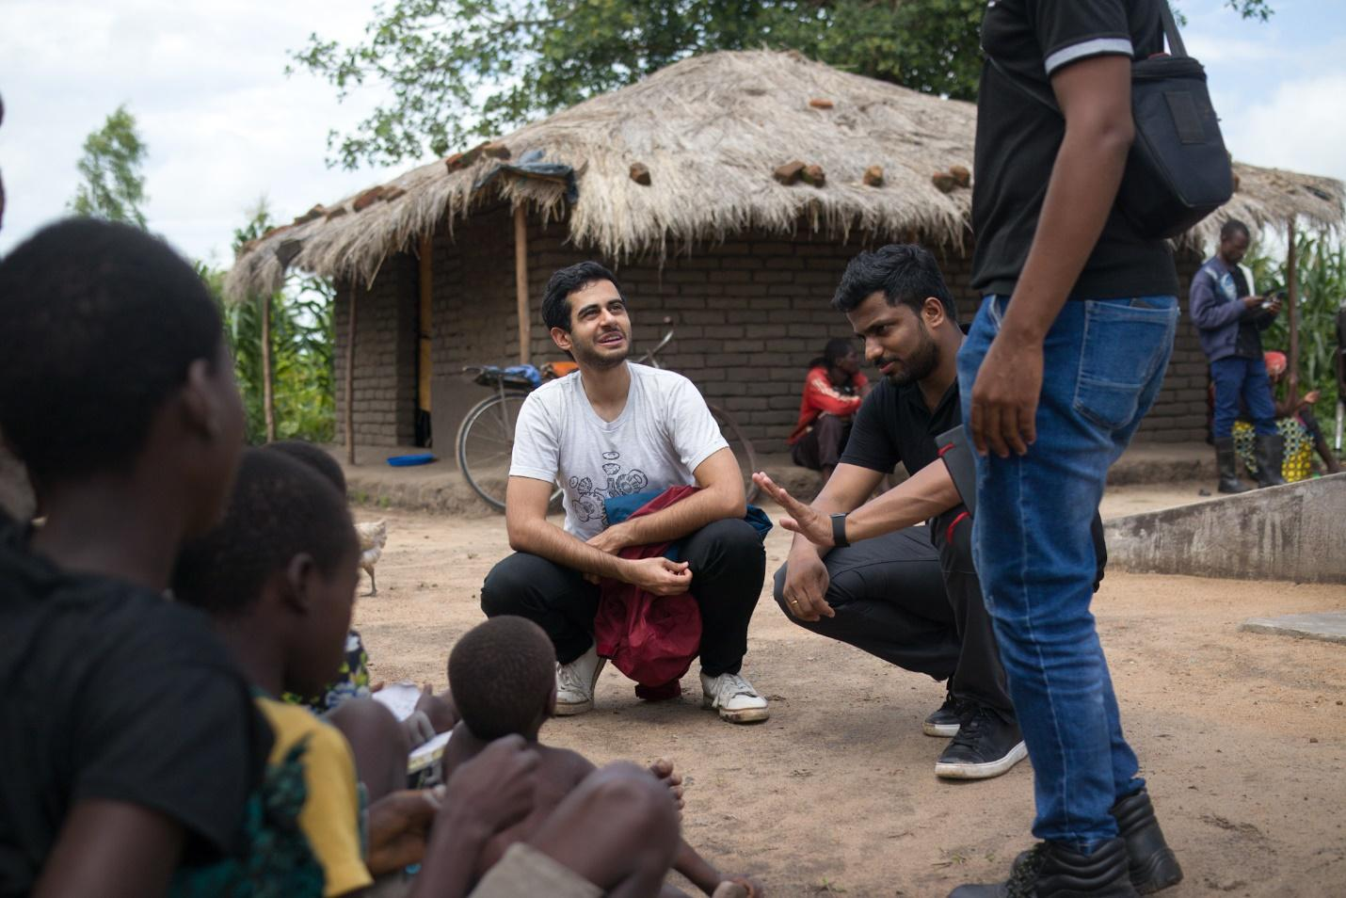Mud Bricks Houses, Co-Founder & Chairman, Madhav Datt and Co-Founder & CEO, Kaushal Shetty
Although the ban has posed challenges for local communities, it has also presented an opportunity for Nostos houses to showcase the potential for innovation and creativity by using alternative materials and techniques. We are helping to pave the way for a more sustainable and resilient future for the people of Malawi.
At Nostos Homes, we have developed a unique approach to emergency housing that addresses both environmental concerns and the needs of the local community. Our modular homes are designed using "LEGO-like" construction techniques and are made from materials that are 90% recyclable. This approach enables us to create safe and weatherproof homes that can be built within days, providing a quick recovery option for people affected by catastrophic floods or earthquakes.
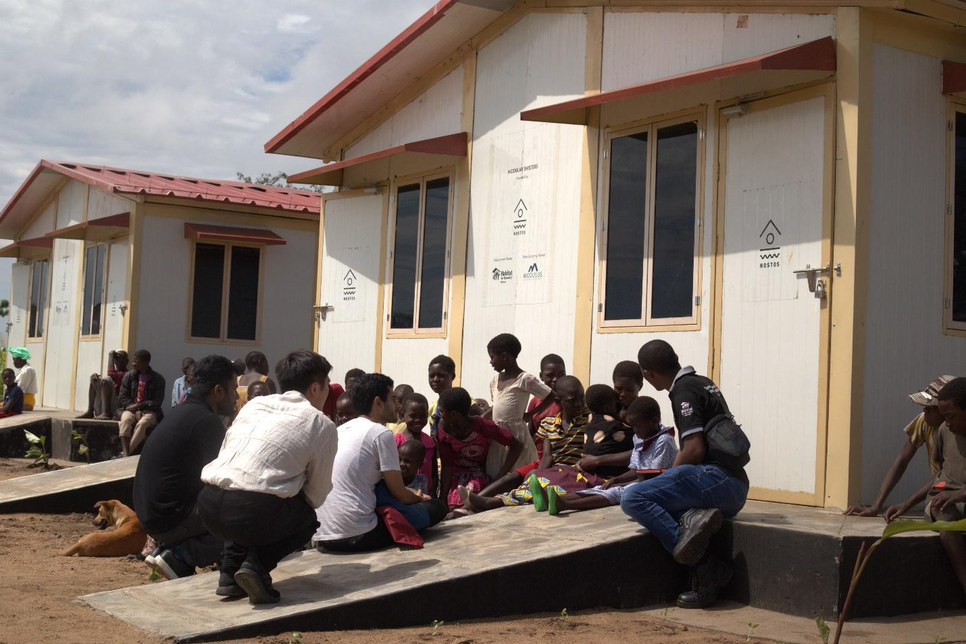
As part of our mission to contribute to local community rebuilding efforts, we collaborated with our manufacturing partner, Modulus Housing, who shared the know-how in house construction with the local artisans. Through this collaboration, the local artisans had the opportunity to learn and build together with them. In my conversation with Felix Mtambalika and Davie Nankhonya, local artisans who helped with the housing construction, mentioned that: "Modulus taught us the techniques on constructing the Nostos houses, it was very straightforward and easy to learn." It was a success as they managed to construct one on their own.
Davie and Felix are among the five local artisans who not only assisted in building the houses but also contributed to future innovation, gained expertise and know-how that they can share with others in the community, fostered a sense of community, belonging, and ownership with the homes they constructed, and ultimately support the long-term maintenance of the houses.
During our visit, we also engaged with the beneficiaries in improving the housing design, delivery, and deployment. Community involvement is a crucial aspect that distinguishes us from others. Instead of entering a new region and dictating our methodologies for local living, we emphasize co-creation and actively engage local communities in the home-building process. These cooperative dialogs are vital, as they allow us to gain a deeper understanding of community needs and challenges. Through one of these conversations, I have also discovered that the flood-prone area lacked alternative sustainable and secure building materials. Additionally, constructing traditional mud-brick homes takes years and leaves families with heavy debt burdens. As a result, the implementation of Nostos homes is vital for offering safe and weather-resistant shelter.
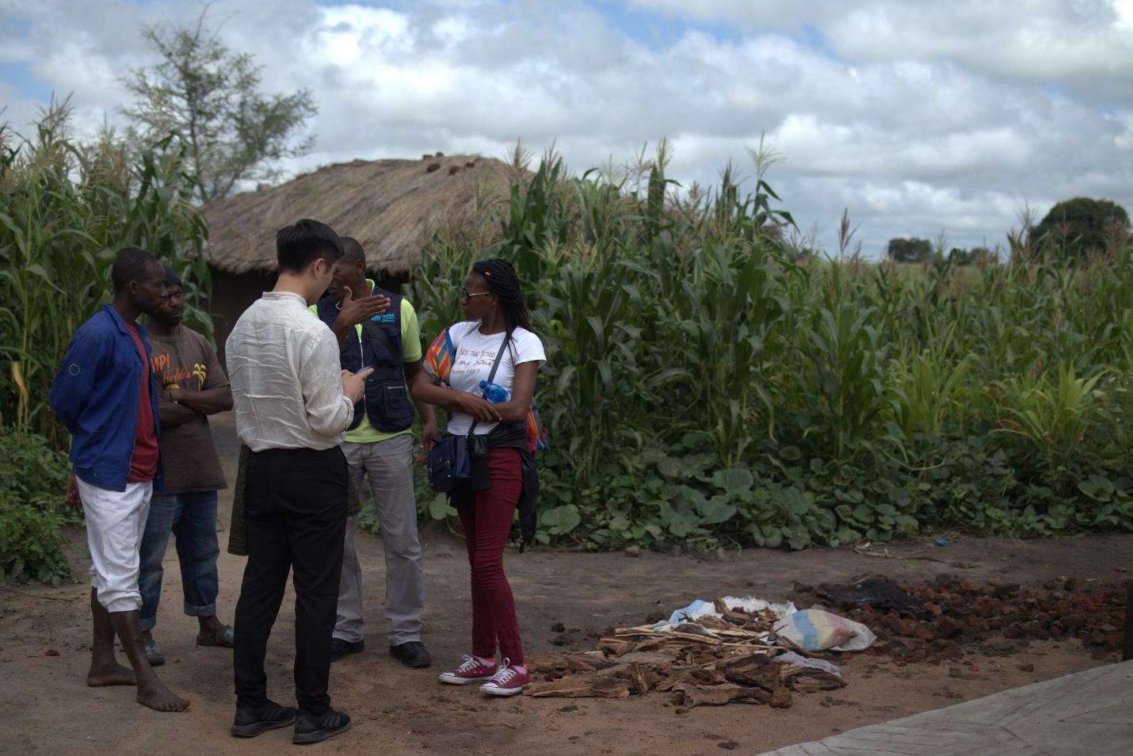On the left: Two of the local artisans that helped construct the houses, Davie Nankhonya and Felix Mtambalika.
During a separate discussion with the Malawi government and Habitat for Humanity Malawi, we explored the potential for integrating local resources and businesses into the manufacturing process of Nostos houses. This approach not only helps to rebuild the local community but also reduces costs associated with materials and logistics, allowing for the maximum utilization of each dollar donated towards the cause. The meeting concluded successfully, as we received the full support of the Malawi government on our future deployment plans.
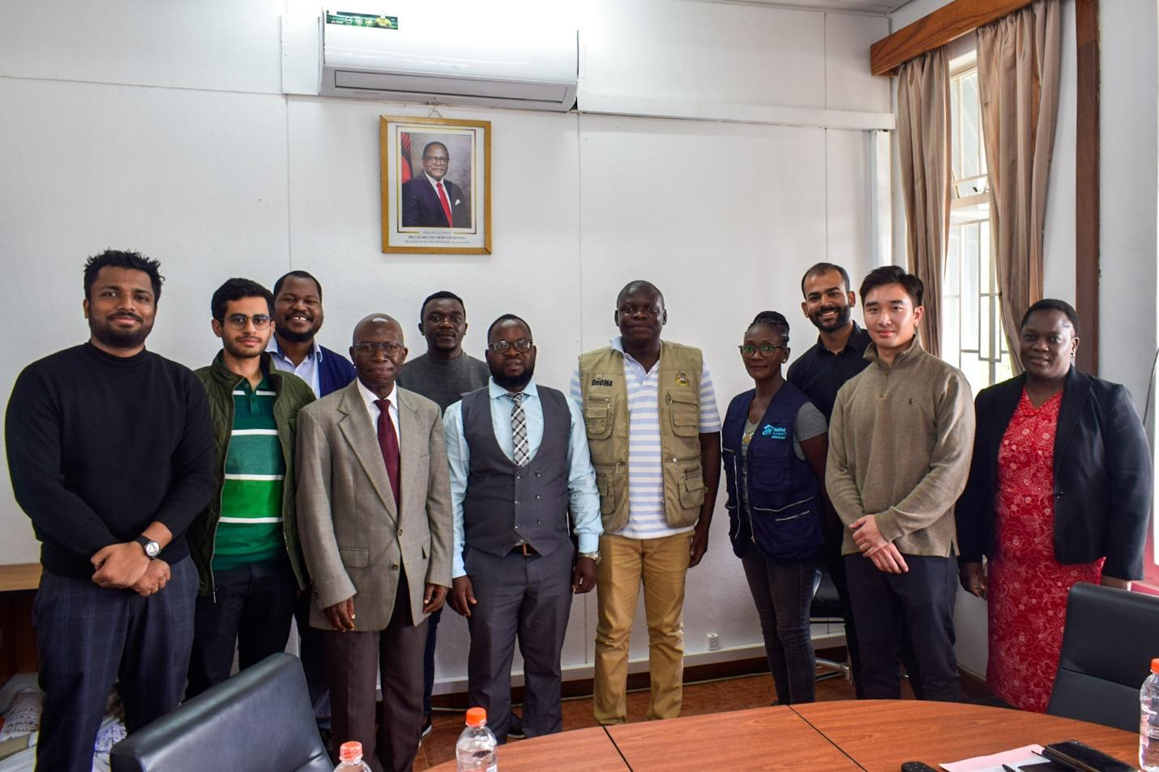Peter Chimangeni, Director at the Department of Disaster Management Affairs, Government of Malawi, alongside Habitat for Humanity Malawi and the Nostos team.
One key aspect of our vision is a commitment to rebuilding communities from the ground up, starting with one of the most basic human needs: a place to call home. By focusing on this fundamental building block, we hope to create a ripple effect that will lead to broader social and economic development in the region we deploy in
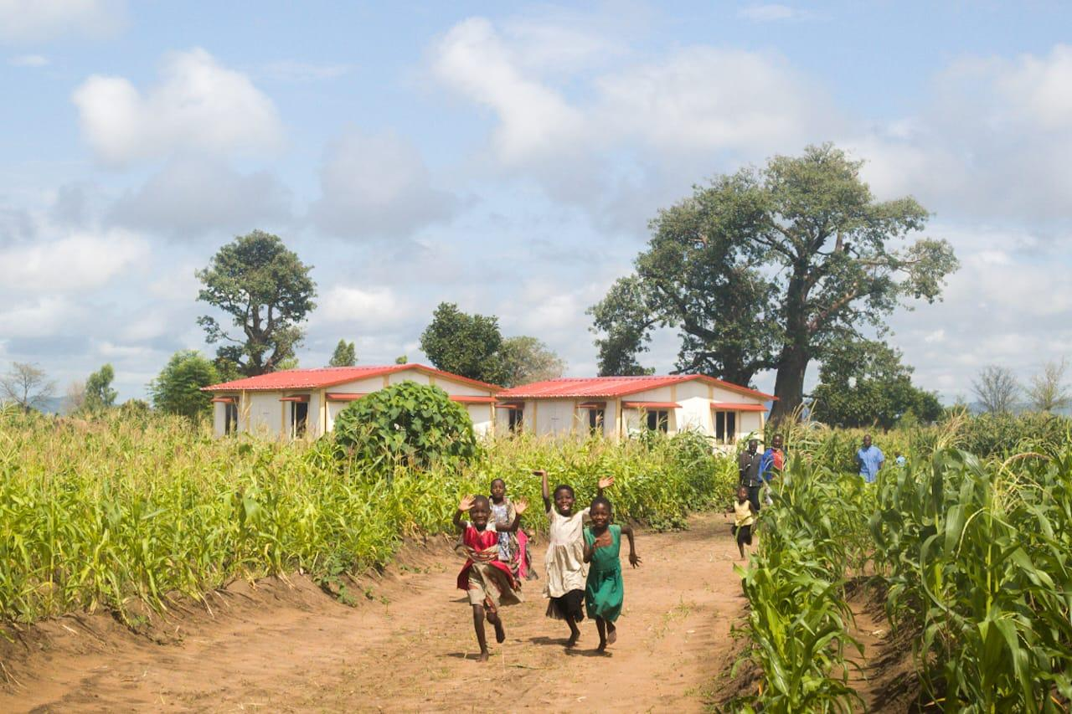The homes have brought hope and laughter back to Phalombe, Malawi, an area ravaged by cyclone Gombe. Children run and wave outside the Nostos community that has provided their families with 350,000 nights of shelter.
$1 spent on Nostos’s climate-resilient homes produces an
estimated return of $15 when the impact of stable employment, health and
education are tallied up.
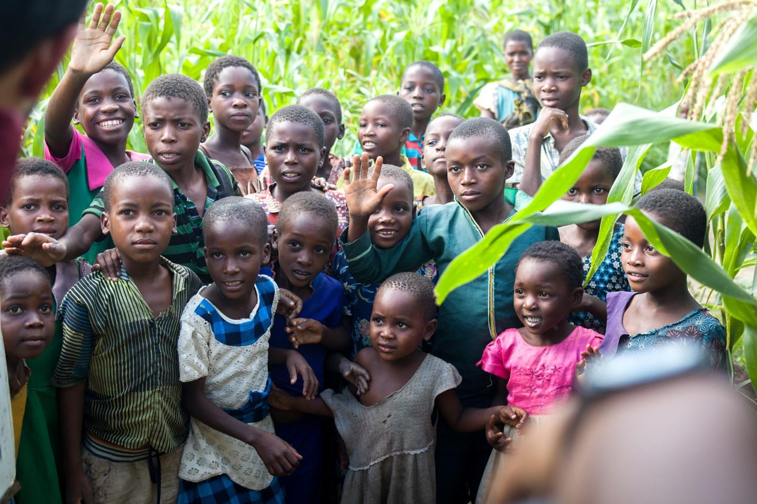
About Nostos Homes:
Nostos Homes is a non-profit organization dedicated to providing safe and affordable housing to refugees and displaced individuals in need. We believe that everyone deserves a place to call home, and we work tirelessly to make that a reality for those who have been forced to flee their homes due to conflict, persecution, or other forms of violence. Our team and dedicated volunteers and staff of our partnership organizations work around the clock to identify, secure, and furnish suitable accommodations, ensuring that each individual or family has access to the basic necessities of life. At Nostos Homes, we are committed to provide more than just a roof above their head, but also with privacy, dignity and a brighter future for those in need, one home at a time.

In order to continue expanding its reach and impact, Nostos Homes is actively seeking partnerships and collaboration with like-minded individuals and organizations.

If you are interested in joining this important mission, let's talk.
Reach me at felix@nostoshomes.org.

