Media Invite
Thousands of Service people across the country will be considering their next career moves – a welcomed boost when you consider the amount of roles industry are trying to fill.
If you would like access to interview those who are leaving the Armed Forces and the companies who proactively see their potential, then you would be very welcome to attend our National Careers Fair in Catterick on 30th March. There are many attendees expected and over 70 companies exhibiting from a variety of business sectors.
Companies exhibiting include, Aldi, DHL, G4S, Next, Thames Valley Police, Kuehne + Nagel, Hitachi Energy, JLR, all of whom are Forces friendly companies who are actively recruiting service leavers. AIS Survivex and NASC are sponsors of this event with both having a long history of supporting ex-forces personnel and are happy to be interviewed.

Event Details
The BFRS National Careers Fair takes place at Catterick Leisure Centre,
Event: BFRS National Careers Fair @Catterick
Date: Thursday 30th March 2023 from 09.30 to 13.30 hrs
Where: Catterick Leisure Centre, Gough Road, Catterick, North Yorkshire, DL9 3EL.
Online: https://bfrss.org.uk/events/ 780340/

Confirmation
For further information or if you wish to attend please contact Sonja Tombling, at BFRS, on Mobile 07833309393 or email Sonja.Tombling@bfrss.org.uk and we can arrange interviews.

About BFRS

BFRS is a Community Interest Company (CIC), a Social Enterprise that was created to work in support of the Armed Forces Community. We support them by working with companies across the UK that are looking to hire, re-train, and offer career advice to the Armed Forces Community.
We continue to host successful National Employment & Careers Fairs, Company Recruitment Days across the country and various online packages. Our aim is to continuously introduce the Armed Forces Community to companies and try to ensure they are fully aware of the benefits of employing from this community.
A CIC is a business with primarily social objectives whose surpluses are principally reinvested in the business or in the community (for us the Armed Forces Community), rather than being driven by the need to maximise profit for shareholders and owners. CICs tackle a wide range of social and environmental issues. For us it to ensure the AFC are not disadvantaged, due to their service.

Photographs
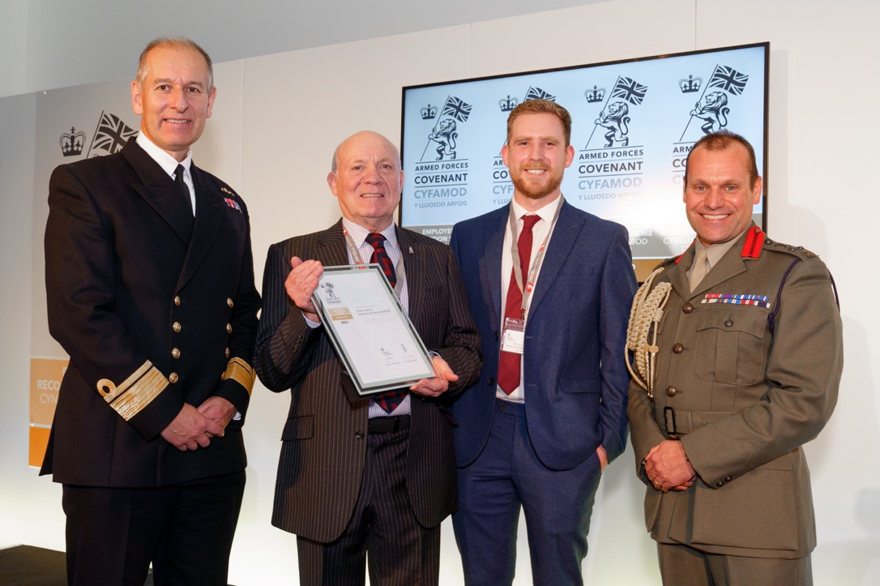

Harry Dean (BFRS CEO) Receiving ‘Gold Standard’ of the Employers Recognition Scheme

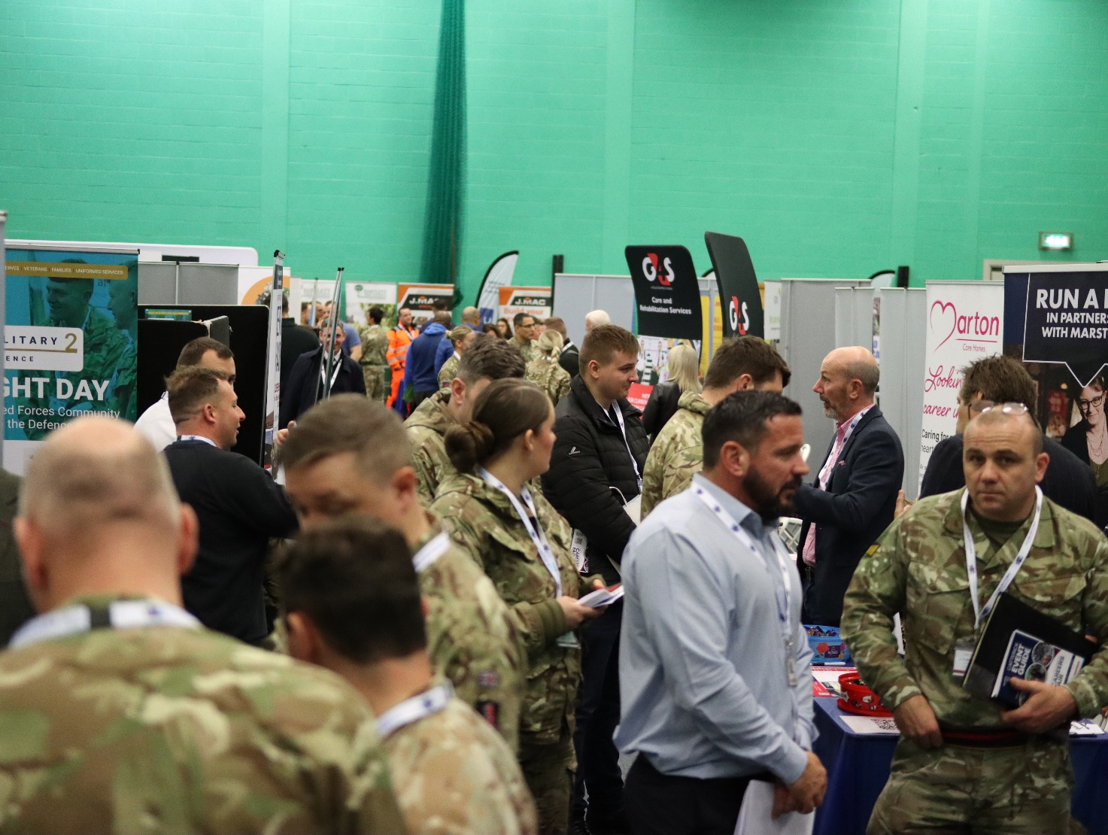
A typical scene at a BFRS Event

