Mohan Electro Casting Private Limited - With 15 years of Impressive Growth, is Expanding further
Management of MEPL, the 65T single piece heavy engineering multi products company, is open for ventures and looking aggressively for expansion in Markets worldwide
Contacts for additional information:
- Arun Murthy Battula, Email: arun@palmyga.com Tel: +91 9182262733
- Anshul Garg, Managing Director, MEPL, Email: anshul_mepl@mepl-mmw.com
- Website: www.mepl-mmw.com
- Facebook: https://www.facebook.com/anshulgargmepl
- Twitter: https://twitter.com/AnshulGargMEPL

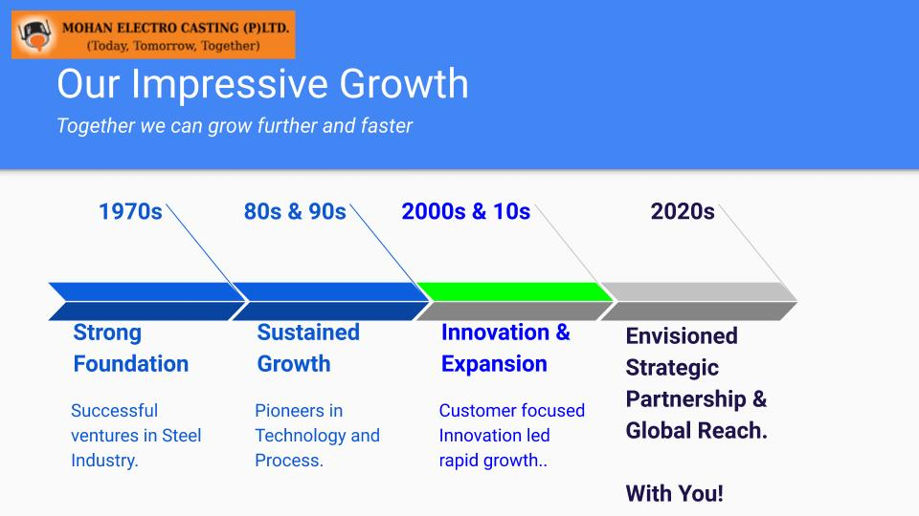

Mohan Electro Casting Private Limited (MEPL) is inviting Leadership Teams of Heavy Machinery and Equipment Manufacturing companies with synergies, for discussions leading to a proposed new Joint Venture.

MEPL has been contributing to India’s economic development as pioneers in Technology and Process, by producing castings machinery for customers globally, upto 65 ton single piece, for more than 15 years.

With Operations Headquartered in Ghaziabad, near New Delhi, MEPL is lead by Subhash Chandra Garg, Founder & CEO and Anshul Garg, Managing Director.

‘’Our management philosophy considers that
customers are our teachers,
quality is our pride,
innovation is our life and
people are the most important asset.’’
- Anshul Garg, Managing Director, MEPL

Anshul Garg, MD, MEPL, has most recently been awarded ‘Top 40 Under 40 EU-India Business Leader’ recognition at EU Parliament in Brussels on 12th of April 2019, by Hon’ble Caroline Nagtegaal, MEP, by a UK based organisation EICBI.

This is just one of the most recent of many awards and recognitions that speak volumes about the value MEPL and its team has added to the business economies in India and Europe.
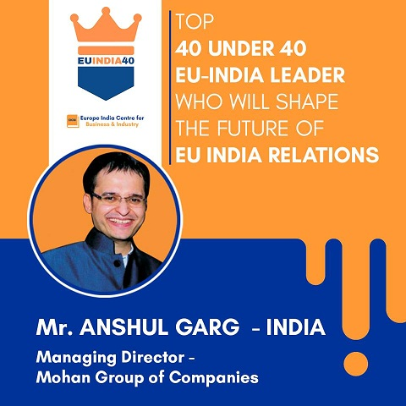

‘’
When I think of engineering, I think of life; When I think of life, I think of basic necessities;
When I think of basic necessities, I think of building the nation together, and for me ‘Engineering is key to Success’
‘’
says Anshul Garg, MD, MEPL

In his initial years of career, Anshul succeeded in developing international relations & presence with Germany, Belgium and France based companies like Loesche Gmbh (Germany), Gebr Pfeiffer (Germany), CMI-FPE (Belgium), Siemens-Vai (France), FCB Ciment (France), SMS Siemag (Germany) to supply large & special steel components for Rolling Mills and other.

Anshul always believes that empathy is your greatest asset - as a leader and an entrepreneur - advises to take calculated risks, be resourceful and follow up to succeed with best life & corporate governance. Now he is gearing up to prepare himself and his company to handshake with Large Scale Engineering company having presence to set up Steel Mill Plants worldwide.

MEPL today has world class
- Machine Shop Facilities
- Steel Manufacturing Process
- Metal Casting Process
- Making of Steel Casting
- Foundry Facilities
A few pointers to MEPL’s delivers include
- Cement Mill Equipments
- Power Plant - Hydro
- Rolling Mill Equipments
- Sugar & Steel Equipments
- Sponge Iron Equipments
Subhash Chandra Garg, and Anshul Garg also actively engage in ensuring MEPL’s Corporate Social Responsibilities are met. MEPL’s CSR activities are around:
- Eradicating extreme poverty and hunger
- Promotion of education
- Building employment enhancing vocational skills and social business projects
- Promoting gender equality and empowering women
- Reducing child mortality
- Combating AIDS, Malaria and other diseases
- Ensuring environmental sustainability
- Support to Central and State Government funds set up for Socio-economic development
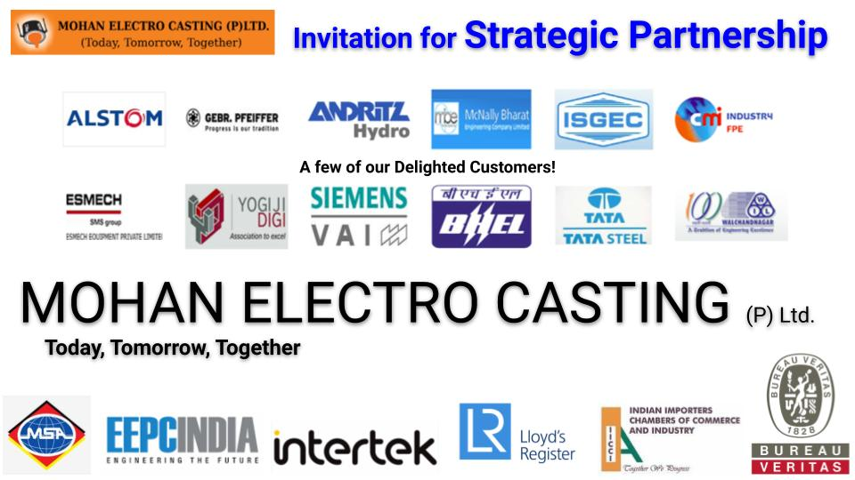

‘’The Growth factors for Manufacturing sector in India are now very bright for companies across the world to enter into partnerships and joint ventures with companies with strong growth history like MEPL’’ says Anshul Garg, Managing Director of MEPL, who is aggressively working on expansion plans.
Contacts for additional information:
- Arun Murthy Battula, Email: arun@palmyga.com Tel: +91 9182262733
- Anshul Garg, Managing Director, MEPL, Email: anshul_mepl@mepl-mmw.com
- Website: www.mepl-mmw.com
- Facebook: https://www.facebook.com/anshulgargmepl
- Twitter: https://twitter.com/AnshulGargMEPL
- MEPL Head Office Contact Details: http://mepl-mmw.com/contact.php

This Press Release is released by

Mohan Electro Castings Private Limited,
C-225
B.S. Road Industrial Area,
Site 1, Ghaziabad - 201009
(U.P), INDIA.

