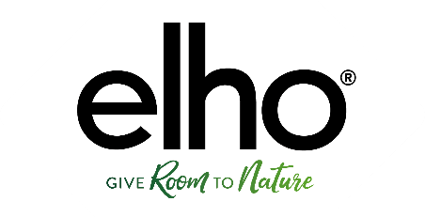

Press statement
Safety warning
elho urges consumers to remove greenville planthangers from the (balcony) railing

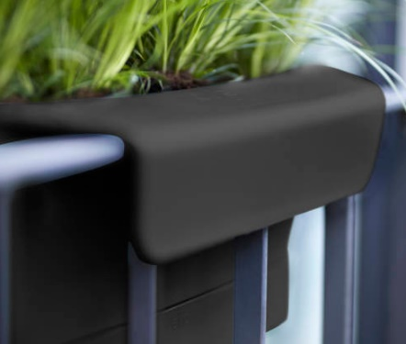
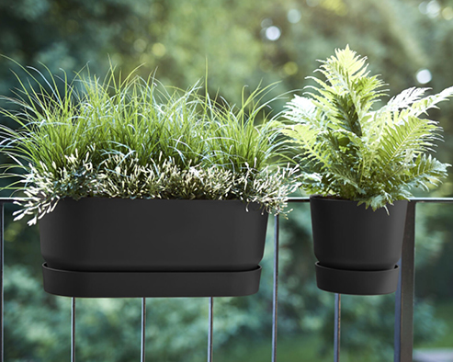

Safety risk
elho urges consumers who have an elho greenville planthanger (this is stated at the bottom of the planter) to remove this product from their (balcony) railing because this planthanger could lead to unsafe situations.
It concerns the long and single versions that are available in 5 colors and are on the market since January 2020.
Due to an error in the design in combination with a high temperature outside, the balcony hook can deform. This makes it possible for the elho greenville plant hanger to fall off a (balcony) railing. All other elho products (including those with a suspension system) meet all quality requirements and are therefore safe.
Action for the consumer
elho urges consumers who have an elho greenville planthanger to remove the product and report this to elho Consumer Service via contact@elho.nl stating ‘recall elho greenville plant hanger’. The Consumer Service team of elho will advise you how to return the product and provide you with a refund.
elho sets high standards for the safety and quality of its products and therefore apologizes for this inconvenience.

Contact details
For questions, consumers can contact the Consumer Care department of elho on the number: +31 13 751 57 50 (during office hours) or send an email to contact@elho.nl.

Not for publication
For press inquiries, please contact:
Emily Verdoorn, elho brand manager, emily.verdoorn@elho.nl
www.elho.com

