Parkopedia partners with Voltality to Deliver Real-Time EV Charging Data Across South East Asia, Giving OEMs a Competitive Edge in High-Growth Markets

- Collaboration between Parkopedia and aggregator Voltality simplifies the process of finding charging across 4,500 locations in four high-growth South East Asian markets
- Service provides drivers with reliable EV charging data, including locations and real-time availability to streamline the process of searching for, navigating and utilising chargers
- This can help enhance the appeal of EVs in South East Asia, an increasingly important region for newer EV brands as they compete for global market share.

24 September 2026 - London, UK / Singapore
Parkopedia by Arrive and Voltality today announced a collaboration to deliver auto-grade, real-time EV charging data across four of South East Asia's fastest-growing automotive markets. The collaboration gives OEMs - particularly Chinese automakers competing for market share across the region - a ready-made, localised charging solution that can be integrated directly into in-car systems.
The partnership covers 4,500 charging locations, 15,000 connectors and 23 Charge Point Operators (CPOs) across Vietnam, Thailand, Singapore and Malaysia, with live availability and connector-level detail delivered to drivers within the vehicle.
Addressing a Critical Gap for OEMs Expanding Beyond China
For Chinese automakers currently driving much of the global EV transition, delivering a premium, localised digital experience outside of their home market has been a significant operational challenge. Charging infrastructure in South East Asia has historically been fragmented, with inconsistent data quality making it difficult for OEMs to offer drivers a reliable, connected experience.
This partnership directly solves that problem. Voltality aggregates live data from disparate charging networks across the region and translates it into a consistent, verified data stream. Parkopedia then delivers this to OEMs in auto-grade quality - meaning no manual updates, no phantom chargers and no degraded driver experience. Chinese OEMs can bypass the complexities of building local data partnerships from scratch and instead go to market with a proven, high-quality solution.
South East Asia: A Strategic Battleground with Strong EV Tailwinds
The timing is significant. EV adoption in South East Asia is accelerating faster than in many more established markets. In 2025, EVs accounted for 45% of new car sales in Singapore, 38% in Vietnam and 21% in Thailand - outpacing the UK (33%) and the United States (under 10%) for the same period.¹

Vietnam and Thailand represent particularly large addressable markets, with populations of over 100 million and 70 million respectively, and considerable room for growth in vehicle ownership. For OEMs able to offer a seamless, high-tech in-car experience, the opportunity to win first-mover loyalty among new EV buyers is substantial.
Highlighting the value of this partnership, Jaap van den Hoek, Global Head of Partnerships at Parkopedia, stated: “EV uptake across South East Asia is rapidly increasing, but infrastructure has historically lagged behind. Our partnership with Voltality allows us to provide high-quality, real-time charging data that removes this friction. For OEMs looking to capture market share in this vital region, we provide a ready-made, localised solution that ensures their drivers have the confidence to charge anywhere, matching the premium digital experience they offer domestically.”
Kristoffer Jacek Soh, CEO at Voltality, added: “Chargers are only valuable when drivers know where these are, there is availability and drivers can park in that location. By connecting VoltNet to the platform drivers already trust in their vehicle, every operator on our network becomes visible when they are most needed.”
CPOs connected to the Voltality network also benefit directly as their 15,000 charging points become visible within in-car systems across four markets without requiring any changes to their existing infrastructure.
Looking ahead, Parkopedia and Voltality plan to expand coverage into additional markets across the region. In-car payment functionality for EV charging is expected to follow, bringing parking and charging together as a fully integrated, end-to-end in-car experience.
¹16/12/25 ASEAN emerges as a new leader in global EV adoption, https://ember-energy.org/latest-updates/asean-emerges-as-a-new-leader-in-global-ev-adoption/

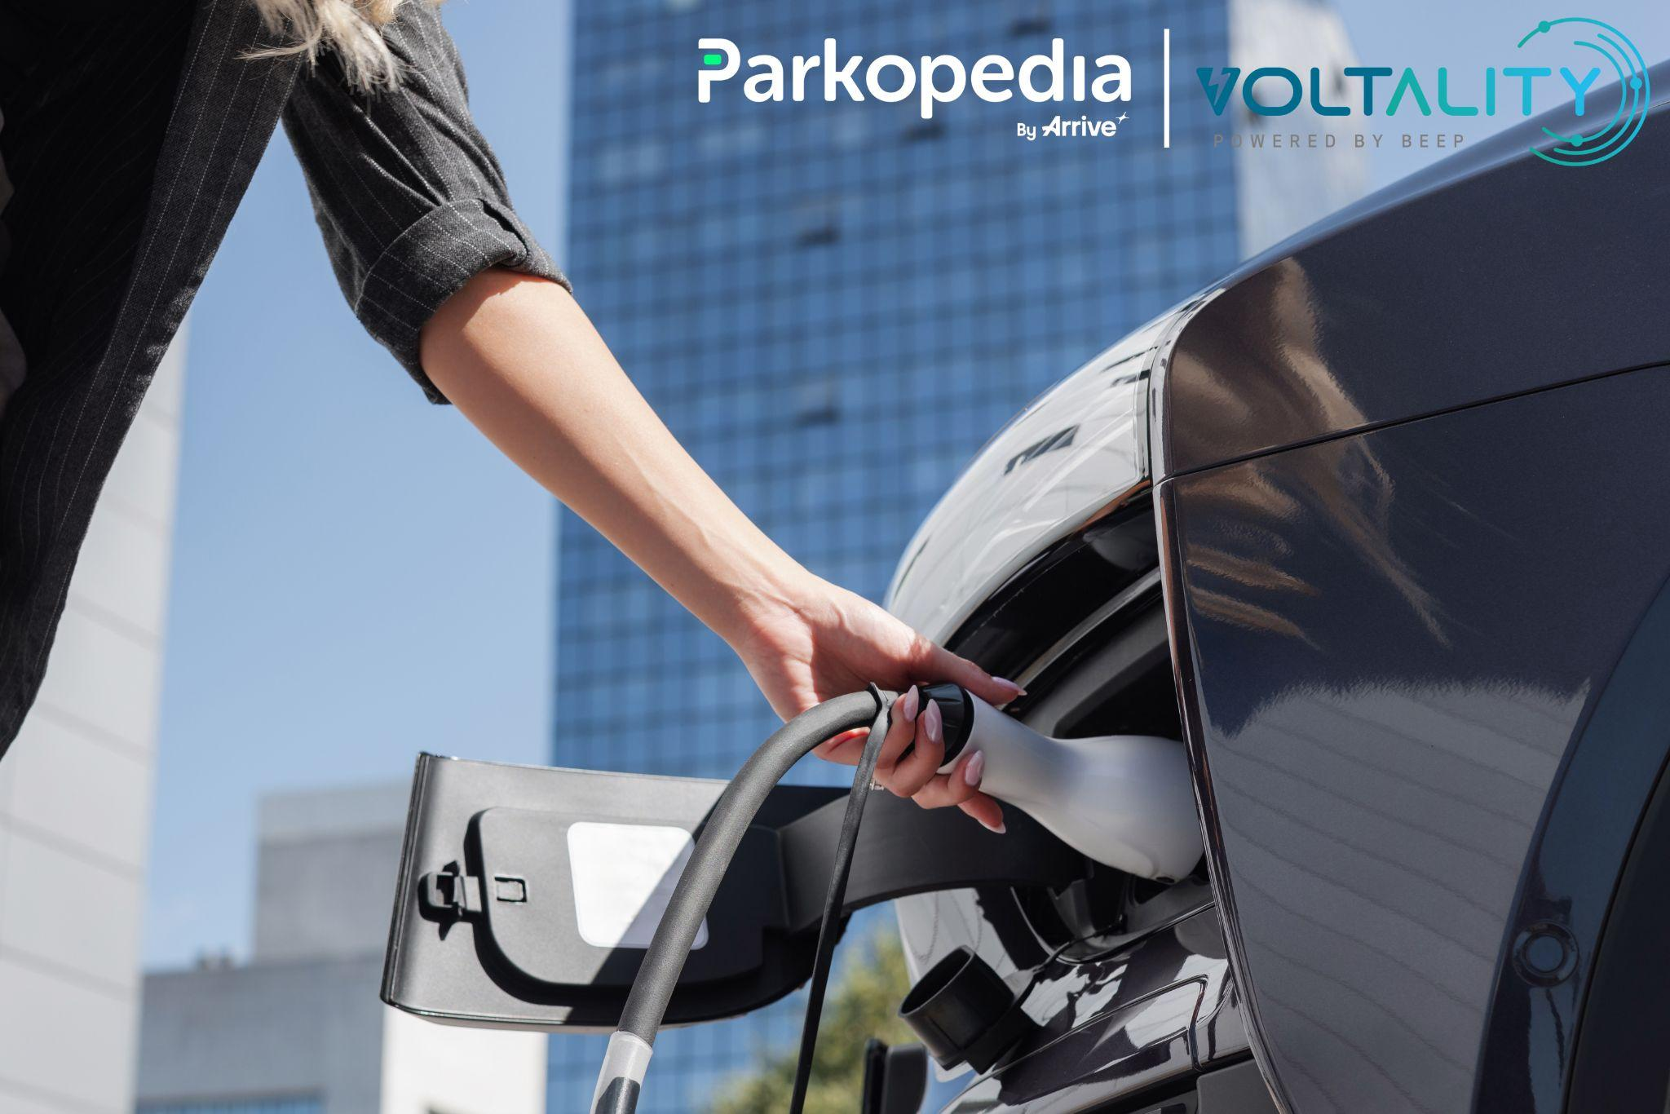
ENDS
About Parkopedia
Parkopedia, part of the global mobility platform Arrive, is the world’s leading provider of connected‑car services, trusted by automakers, organisations and millions of drivers. To make cities more livable, Parkopedia helps drivers find and pay for parking, EV charging, fuel and tolls across 90 countries. It is also developing indoor maps that enable end-to-end navigation for drivers and autonomous vehicles without GPS. Visit business.parkopedia.com for more information.
About Voltality
Voltality, the eMobility subsidiary of Beep, is Southeast Asia's first and leading EV charging interoperability platform focused on delivering a borderless, interoperable charging experience for businesses and drivers alike. Its product suite — VoltNET, VoltNOW, and VoltPOS — is designed to eliminate the fragmentation that defines the region’s EV landscape by making charging as convenient, or even better, than refuelling. Together these products have enabled the distribution of more than 5GWh of energy across the region, all through Voltality’s eMobility platform. Visit www.voltality.io for more.

Parkopedia Global Media Contact
Christofer Lloyd
PR and Communications Manager
T: +44(0)7762300016
E: christofer.lloyd@parkopedia.com

Voltality Media Contact
Hạ Nguyễn
Marketing Lead
T: +84923230989
E: ha.nguyen@voltality.io

