FOR IMMEDIATE RELEASE

Contact: Hasegawa Seiichi
Call: 81-3-3843-8814
Mail: hasegawa-s@epoch.jp

Sylvanian Families Launches Global Holiday Photo Contest 2016

Marking its 30th year in history, globally famous Sylvanian Families who are loved and played in more than 50 countries are giving back to the community. Photo submission will end on December 10, 2016, Saturday.
Save the dates!

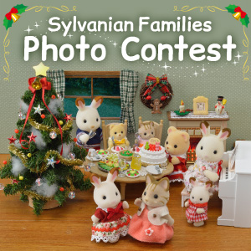

The Sylvanian Families Global Holiday Photo Contest
(http://sylvanianfamilies.net/global/photocontest/2016holiday/) is open to everyone who has an Instagram account and a creative mind. Here’s how to get involved:

- Keep in mind that the theme of this year’s photo contest is “Sylvanian Families Holiday”.

- Set up your Sylvanian Families collection and take your best shot.

- Do not forget to include the hashtag “#SylvanianHoliday”

Winners will be announced on December 10, 2016. The best photographs will be released on the official Sylvanian Families website and the official Sylvanian Families Instagram account.

It’s the upcoming Holiday season for our Sylvanian Families. It’s up to you how you can make your shot unique and totally awesome! The fun and entertainment must be captured. It all depends on your creativity! The goal is to connect all the Sylvanian lovers and enthusiasts out there to share and spread fun of Sylvanian Families in a global scope.

“Sylvanian Families live in a world surrounded by nature. They make the childhood memories of many children more lively and beautiful. ”

###

About US

Epoch Co., Ltd is a global toy manufacturer. It has more than 50 years of experience in the industry. These Sylvanian Families products are distributed around the world.

For any related info about the website please contact:

Contact: Hasegawa Seiichi
Call: 81-3-3843-8814
Mail: hasegawa-s@epoch.jp

