Volunteers needed for Get Growing’s food growing revolution!
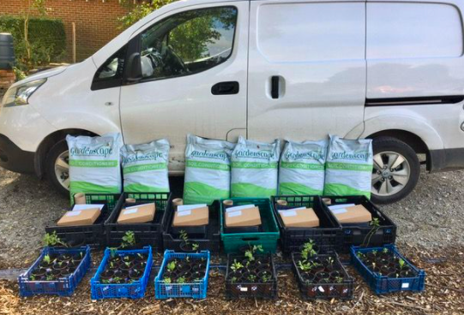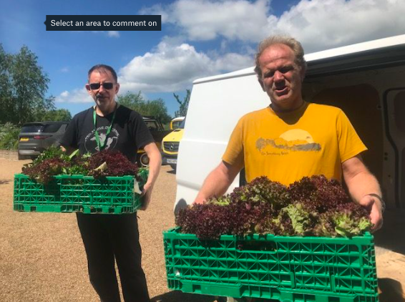
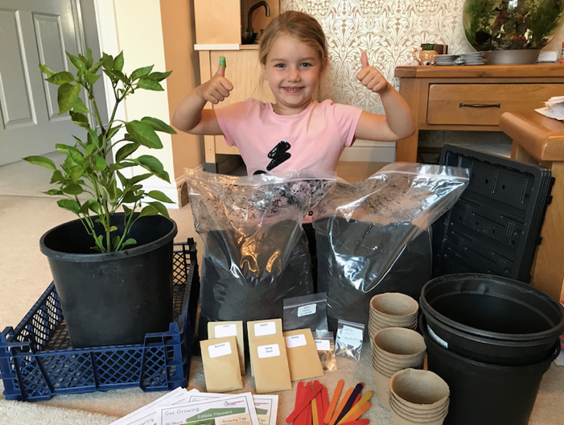
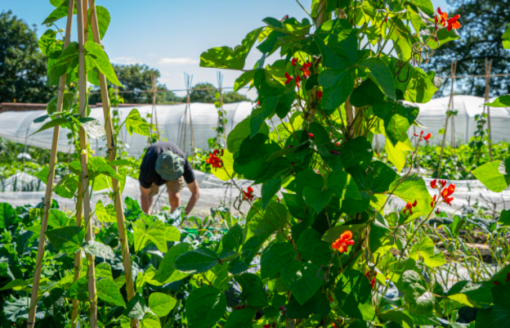
- Grow kits ready to be delivered
- Founder, James, and volunteer Ash, deliver food to food banks
- Volunteer Cathy weeding the polytunnel
- A Volunteer harvesting in the garden
- A get growing kit arrives with its new owner

Hi res Images and image credits available on this link (please credit photographer, Ann Chown)

Volunteers needed for Get Growing’s food growing revolution!
Spring is springing, and a project to share Nature’s bounty is putting up shoots across Rother, Hastings and West Kent. Hands of Hope Charity’s ‘Get Growing’ project gives people kits to grow their own food in whatever space they have, from a windowsill to an allotment.
The idea for Get Growing was planted in 2020 in response to Covid 19, when Hands of Hope volunteers delivered more than 250 free grow kits with funding from National Lottery, Kent Community Foundation, Sussex Community Foundation, Card Factory in Hastings and The Fore. There have been over 500 registrations for Get Growing 2021 and over 1000+ kits will be delivered to schools, early years, families, lone residents, and care homes.
‘There are endless benefits to growing your own food’, says Hands of Hope Trustee, Mandy Doran. ‘It reduces food waste and saves money. It cuts food miles, helping the environment. If you grow too much you can share the surplus. Growing your own connects you to nature and improves mental health and wellbeing. Best of all, anyone can do it – you don’t even need a garden.’
Kerry, whose daughter is pictured, said ‘Get Growing showed my children how food grows. It lifted our spirits to grow something from seed, nurture and eat it.’
Those new to gardening or worried they don’t have green fingers can access growing tips and help from Get Growing’s website whenever they need.
James Doran, Founder of Hands of Hope Charity says, ‘Get Growing aligns with the NHS’s 5 ways to wellbeing: Connect, Learn, Be Active, Take Notice and Give Back.’
Get Growing also grows tonnes of fresh, organic food in its heritage walled kitchen garden in Hawkhurst. This is harvested and delivered to local food banks and community support groups.

‘A project of this scale couldn’t happen without our amazing team of volunteers’, says Mandy. ‘If you have time on your hands and want to get involved – we’d love to hear from you.’

Volunteers are needed at the garden in Hawkhurst to help prepare grow kits and harvest produce for food banks. Delivery Drivers are also needed to drive Get Growing’s electric van and deliver the grow kits to Rother, Hastings and West Kent.
If you don’t have spare time, but still want to support Get Growing, you can make a donation at hohcharity.co.uk – a £10 donation will pay for a grow kit for someone in need.

----Ends----
For more information contact Mandy Doran, Trustee, info@hohcharity.co.uk
07968 333 097
https://www.hohcharity.co.uk/
https://get-growing.co.uk/
Images and image credits available on this link (please credit photographer, Ann Chown)

