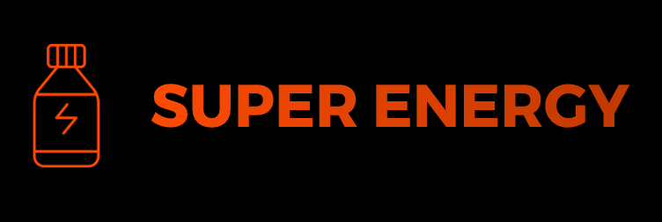
STRICTLY EMBARGOED UNTIL 25/07/2025 00:01

Red Bull Rival ‘Super Energy’ Launches In The UK

Introducing Super Energy: The New Drink to Rival Red Bull in the UK Market

- Expected to sell 150 million cans a year across the UK
- Launching in major UK supermarkets
- Founded by ex Coca Cola executive
- Aims to take half of the energy drink market share

London, UK - 01/01/2025 Super Energy, the latest player in the energy drink market, has officially launched in the UK, promising to provide consumers with an unparalleled energy boost without the added sugar.

Unlike many of its competitors, Super Energy contains caffeine and other performance-enhancing ingredients to give consumers a much-needed energy boost, without the added calories and sugar that can lead to energy crashes and other health problems. The drink has been designed to appeal to a broad range of consumers, including students, athletes, and working professionals.

"We are thrilled to introduce Super Energy to the UK market," said the company's founder, John Smith. "We believe that our product offers a unique and healthier alternative to traditional energy drinks, without sacrificing the energy boost that people have come to expect from these types of products."

Super Energy is now available for purchase in Tesco, Asda, and around 50 pubs across the UK. The company is also exploring partnerships with other retailers and distributors to expand its reach in the coming months.

"We're excited about the potential for Super Energy to become a major player in the UK energy drink market," added Smith. "Our goal is to provide consumers with a product that delivers the energy boost they need to power through their day, without the added sugar and calories that can come with other energy drinks."

Super Energy's launch is expected to generate significant interest among consumers and industry insiders alike, as the company looks to take on established players like Red Bull and Monster in the highly competitive energy drink market.

For more information on Super Energy and its product offerings, please visit the company's website at www.superenergy.com.

PRESS CONTACT:
John Smith
Founder, Super Energy
j.smith@superenergy.com
+44 (0) 1234 5678

PRESS IMAGES/ VIDEO:
Access here: https://wetransfer.com/

