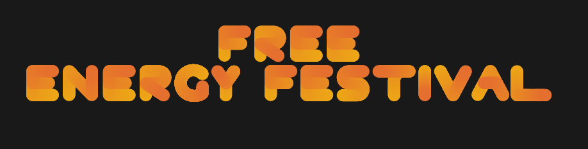
STRICTLY EMBARGOED UNTIL 25/07/2025 00:01

Free Energy Music Festival Returns to Barcelona in 2025 With Shakira Headlining

Free Energy Music Festival is back in 2025

- Shakira, Rolling Stones and Editors to headline
- Five stages with music for everyone
- Three date event will host global artists

Barcelona, Spain - 01/01/2025 Barcelona, Spain - The city of Barcelona is set to welcome one of the world's most anticipated music festivals on September 5th, 6th, and 7th, 2025. This annual event attracts music lovers from across the globe and is known for its high-energy performances, unique atmosphere, and world-class talent.

The lineup for the festival features some of the biggest names in the music industry, including global superstars Shakira, The Editors, Rolling Stones, Beatles, Rosalia, and many more. With music across five different stages, there is something for everyone, from dance to techno, rock, and pop.

This year's festival promises to be bigger and better than ever before, with a diverse range of artists set to perform over the three-day event. Music fans can expect to experience an unforgettable weekend of non-stop entertainment, with top-notch sound systems, breathtaking light shows, and an unparalleled atmosphere.

Tickets for the festival are on sale now, with general admission tickets starting at €150 each, and VIP tickets priced at €600. VIP ticket holders will have access to exclusive viewing areas, premium seating, private bars, and luxury facilities.

The festival is expected to attract visitors from all over the world, and tickets are selling fast. Don't miss out on the chance to experience one of the world's most exciting music festivals. Get your tickets today and join us in Barcelona for a weekend of unforgettable music and memories.

For more information and to purchase tickets, please visit the festival's official website at www.freeenergyfest.com

PRESS CONTACT:
John Smith
Founder, Free Energy
go@freeenergyfest.com
+44 (0) 1234 5678

